# ETHER SYNTHESIS: CONVERSION OF ACETAMINOPHEN INTO PHENACETIN

**Required Pre-lab readings:** McMurry sect 13.9

**Techniques you must be prepared to use:** reflux; extraction; rotary evaporation; recrystallization.

In the reaction today you will be converting 4-acetamidophenol (Acetaminophen) into ethyl 4-acetamidophenyl ether (Phenacetin). Both compounds are ingredients in many over-the-counter analgesics. This reaction is an example of the Williamson ether synthesis. For most ether syntheses strong bases such as amide ion (NH2)are necessary to generate the nucleophile. In today’s reaction the relatively weak base carbonate is used. Why does carbonate work?

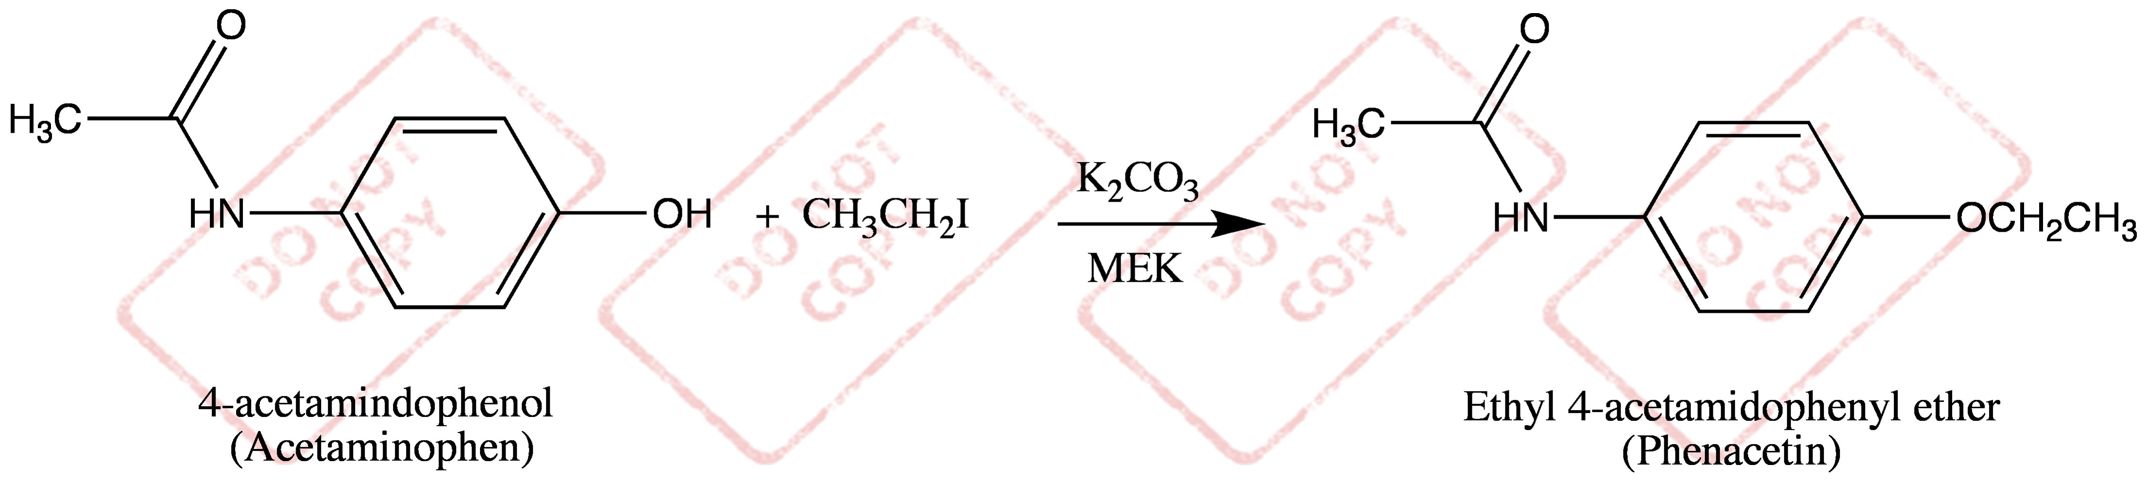

In a 50 mL round-bottomed flask place 12 mmol of liquid ethyl iodide, 15 mL of methyl ethyl ketone (2-butanone; MEK) as solvent, Acetaminophen (1.5 g; ?? mmol.), and powered anhydrous K2CO3 (2.5 g; ?? mmol). Mechanically stir this mixture and reflux for 1 hour. After the reflux is complete cool the flask in an ice/water bath for approximately 5 min and gravity filter the contents into a separatory funnel. Use small amounts of diethyl ether (approximately 5 mL) to insure that you have quantitatively transferred all the organic material from the flask to the funnel. Wash the organic phase with 5% aq. NaOH (what is the purpose of this step?), then dry it (Na2SO4) and decant into a flask and remove the solvents by rotary evaporation. The product is purified by recrystallization from water. Allow the purified product to air dry until next week when its weight and mp can be obtained.

**ETHER SYNTHESIS: CONVERSION OF ACETAMINOPHEN INTO PHENACETIN**

**DATA SHEET**

|  |  |  |  |
| --- | --- | --- | --- |
| **Name:** |  | **Section:** |  |

Overall Reaction (chemical drawing software):

|  |  |  |  |  |  |  |  |  |
| --- | --- | --- | --- | --- | --- | --- | --- | --- |
| Mass of acetaminophen: | |  |  | Theo mmol phenacetin: |  | | | |
|  | |  |  |  | | |  | |
| mmol of acetaminophen: | |  |  | Theo mass phenacetin: |  | | | |
|  |  | |  |  | | |  | |
| Volume of CH3CH2I: |  | |  | Mass recovered phenacetin: | | |  | |
|  |  | |  |  | | |  | |
| mmol of CH3CH2I: |  | |  | mmol recovered phenacetin: | | |  | |
|  |  | |  |  | | |  | |
| Mass of K2CO3: |  | |  | % yield of phenacetin: |  | | | |
|  |  | |  |  |  | | | |
| mmol of K2CO3: |  | |  |  |  | | | |
|  |  | |  |  |  | | | |
|  |  | |  | Experimental mp phenacetin: | | | |  |
|  |  | |  |  | | |  | |
|  |  | |  | Literature mp phenacetin: | |  | | |

Literature source for phenacetin melting point:

Calculations: (notebook)

Show the formal step-by-step "electron-pushing" mechanism for the reaction in this experiment

Attach the 1H and 13C NMR spectra for your starting material and product. Draw the appropriate structure directly onto each spectrum with all non-equivalent nuclei (H’s or C’s, as appropriate) labeled (a, b, c...) for NMR identification. Match each label with the corresponding peak(s) in the spectrum by writing the appropriate letter above the associated peak. Identify any NMR solvent peaks by writing the solvent above them.

1H NMR Spectrum of Product:

Complete the table below for the 1H NMR spectrum of the product. If necessary, use the expanded spectra for multiplicity and coupling constants. For *Identification*, use the same a, b, c... that is used on the spectrum. Do not include solvent peaks in the table.

|  |  |  |  |  |
| --- | --- | --- | --- | --- |
|  (ppm) | Multiplicity | J (Hz) | Number of H’s | Identification |
|  |  |  |  |  |
|  |  |  |  |  |
|  |  |  |  |  |
|  |  |  |  |  |
|  |  |  |  |  |
|  |  |  |  |  |
|  |  |  |  |  |

Supply the missing alcohol, alkyl halide or product for the following ether syntheses. Use Chemical Drawing software and paste your answers into the boxes.

|  |  |  |  |
| --- | --- | --- | --- |
| a. |  |  |  |
|  |  |  |  |
| b. |  |  |  |
|  |  |  |  |
| c. |  |  |  |
|  |  |  |  |
| d. |  |  |  |
|  |  |  |  |
| e. |  |  |  |