**Determining the Mechanism of a Halogenation Reaction:  
Addition of Bromine to *trans*-Cinnamic Acid**

**Required Prelab Readings**: McMurry Chapter 5, Sections 8.2 & 21.2

**Previous techniques that you must know and be able to perform:** suction filtration, melting point, NMR spectroscopy

You will be performing the following reaction:



When an electrophile, such as bromine, adds to an alkene, the addition can take place in a *syn* fashion, in which the two groups add to the same face of the pi-bond, or in an *anti* fashion, where the groups add to opposite faces of the pi-bond, or completely at random, where half the time the groups add half of the time to the same face and half of the time they add to opposite faces. Depending on the mode of addition, *syn,* *anti,* or random and the stereochemistry of the starting alkene, various stereoisomeric products will result. One possibility is a racemic mixture of products. Alternatively, a *meso* compound might be produced. A third possibility is a mixture containing two racemates or a racemate and a *meso* compound. This third possibility is just a combination of the first two possibilities.

The Fischer projections shown above are the two possible diastereomers that could form in the bromination reaction that you will perform. One is the result of a *syn* addition and the other is the result of an *anti* addition mode. Note that each would form as a racemic mixture, (+). You are to determine, based on the melting point of your product, whether one of the pairs of enantiomers is produced or if there is a 1:1 mixture of the two. By knowing which enantiomeric pair is formed or if they are formed as a mixture a plausible mechanism can be proposed. Hint: you can predict the stereochemical outcome of a *syn vs. anti* addition of bromine to alkenes before you step foot into the laboratory.

* *The most time-consuming part of this experiment is setting up the glassware. Be sure all fittings are tight, well-greased, and clamped so as to prevent any escape of bromine vapors into the laboratory environment. An actual set-up is provided for you in the lab for you to look at.*

**NOTE:** You are responsible for calculating the amount of *trans*-cinnamic acid (in grams) equivalent to 4 mmol. You must have this done before you enter the lab.

**Hazards**

Molecular bromine is extremely toxic and corrosive; its vapors are damaging to the skin, eyes and respiratory tract. Wear gloves and UNDER NO CIRCUMSTANCES ARE YOU TO REMOVE THE BROMINE STOCK SOLUTION FROM THE HOOD. Only remove your bromine solution in the stoppered funnel. Sodium thiosulfate reduces Br2 to Br-1. When working with Br2, always keep a bottle of 5% sodium thiosulfate handy for rinsing the skin in case of contact.

**Experimental**

* 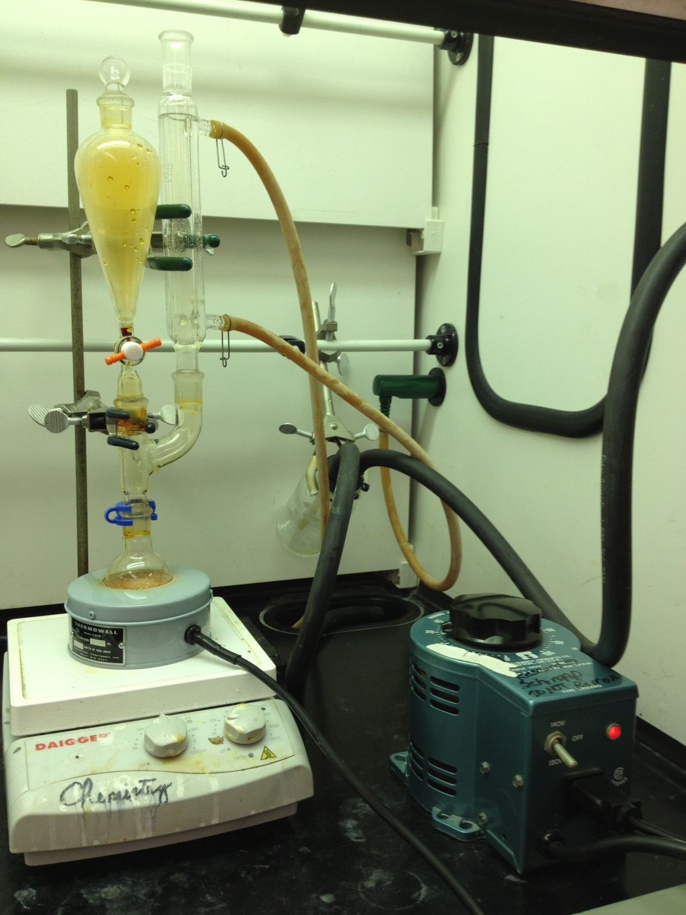Assemble a 50 mL round-bottom flask with a Claisen head, reflux condenser, and addition funnel (picture on right). Into the round-bottom flask, add *trans*-cinnamic acid (4 mmol) and 10 mL of methylene chloride. Add a stir bar.
* Obtain 4.0 mL of a 1.0 M solution of bromine in methylene chloride in the addition funnel. Attach a heating mantle and variac and heat the mixture to a gentle reflux. The variac setting should initially be 25-30% of the maximum. Adjust this setting as necessary until the solution is refluxing.
* While it is refluxing, add the bromine solution at a rate of two drops per second. You need not loosen the stopper on the funnel for the bromine addition due to the high density of methylene chloride. The red-orange color of the bromine should dissipate as it reacts with the mixture. Continue to reflux for an additional 10 minutes after the last of the bromine has been added.
* The color of your final solution should be a very pale yellow. If the red-orange color persists after the 10 min, add cyclohexene dropwise (1-2 mL) until the red color disappears.
* Remove the reaction flask and cool it in an ice bath for 10 minutes with a greased stopper on top. Allow the product, 2,3-dibromo-3-phenylpropanoic acid, to crystallize.
* Meanwhile, disassemble the rest of the reflux apparatus and sit it in the back of your hood to allow the fumes to dissipate. Rinse the glassware with a small amount of sodium thiosulfate to destroy any remaining bromine.
* Collect the crystalline product by suction-filtration, and rinse with a minimal amount of ice-cold methylene chloride. Allow it to air-dry and record the mass and melting range of the product. Have your instructor check the weight of your product and initial this value in your lab notebook. Save all of your product as it is the starting material for next week.

**DATA SHEET**

**Mechanism of Bromination of *trans*-Cinnamic Acid.**

|  |  |  |  |
| --- | --- | --- | --- |
| **Name:** |  | **Section:** |  |

Overall Reaction (including stereochemistry, in perspective [not Fischer]; use chemical drawing software):

|  |  |  |  |  |  |  |  |  |  |  |  |  |  |
| --- | --- | --- | --- | --- | --- | --- | --- | --- | --- | --- | --- | --- | --- |
| Mass of acid: | |  | | |  | | Theo mmol product: | | |  | | | |
|  | | |  | |  | |  | | | |  | | |
| mmol of acid: | |  | | |  | | Theo mass product: | |  | | | | |
|  | | |  | |  | |  | | | | |  | |
| Volume of Br2 sol’n: | | | |  |  | | Mass recovered product: | | | | |  | |
|  | | |  | |  | |  | | | | |  | |
| mmol of Br2: |  | | | |  | | mmol recovered product: | | | | | |  |
|  | | |  | |  | |  | | | | |  | |
|  | | |  | |  | | % yield of product: |  | | | | | |
|  | | |  | |  | |  | | | | |  | |
|  | | |  | |  | Melting point of recovered product: | | | | | |  | |
|  | | |  | |  | |  | | | | |  | |
|  | | |  | |  | | Literature melting point: | | | | |  | |

Calculations (notebook):

Draw the structure of the product directly on its 1H NMR spectrum with all non-equivalent H’s labeled (a,b,c…) for NMR identification. Match each label with the corresponding peak(s) in the spectrum by writing the appropriate letter above the associated peak(s). Label any NMR solvent peaks in the spectrum by writing the solvent above them.

Fill out the table below for the 1H NMR spectrum of the product. Use the same labels (a,b,c…) in the table that were used for identification of non-equivalent protons on the spectrum. You may use the expanded spectrum to determine chemical shifts and coupling constants, but you will only turn in the one spectrum that includes all the peaks. Do not include solvent peaks in the table.

|  |  |  |  |  |
| --- | --- | --- | --- | --- |
|  (ppm) | Multiplicity | J, Hz | Number of H’s | Assignment |
|  |  |  |  |  |
|  |  |  |  |  |
|  |  |  |  |  |
|  |  |  |  |  |
|  |  |  |  |  |
|  |  |  |  |  |
|  |  |  |  |  |

**Post lab excercises (These exercises are designed to help you write your conclusion)**

1. Follow the pattern of the example and use the templates provided to demonstrate which type of addition (*syn* or *anti*) of bromine to *trans*-cinnamic acid results in Isomer I and which leads to IsomeraII. Be sure to write the name of the corresponding isomer (Isomer I or Isomer II) below the Fisher projections.  
NOTE: The question is about mode of addition (*syn* vs. anti), not mechanisms; do not use curved arrows or intermediates to explain your answer. For simplicity you may use Ph for a benzene ring.

For example:







2. a. In ***your experiment*** did the addition take place by a *syn* or *anti* addition mechanism?

b. Use both experimental data and the answer to Question 1 to briefly explain how you know came to your conclusion in part a.

3. Provide the "electron-pushing" mechanism for this reaction and show how both enantiomers are produced. Use perspective representations to draw structures. Assign the R / S configuration to each stereocenter in the products.

4. Using perspective drawings with the correct stereochemistry, redraw the pair of enantiomers you drew in Question 3 and show how each can be redrawn as the Fischer projection of Isomer I, Isomer II, or the enantiomer. Clearly label all stereocenters as R or S.

5. Show the major product(s) of the following electrophilic addition reactions:

|  |  |  |  |
| --- | --- | --- | --- |
| a. |  |  |  |
|  |  |  |  |
| b. |  |  |  |
|  |  |  |  |
| c. |  |  |  |
|  |  |  |  |
| d. |  |  |  |

**Conclusion**

In addition to the items normally found in your conclusion, your conclusion must:

a. Use the NMR and mp data to support that a chemical reaction took place and explain which isomer was the product.

b. Discuss whether the addition occurred by a *syn*, *anti* or random mechanism.  
Explain your reasoning.

c. Explain how the other two mechanisms are excluded by the experimental evidence. How would the experimental results differ for those mechanisms?