**Infrared Spectroscopy**

***Required Readings*:**

* **McMurry: Sections 10.5-10.8**
* **Padias: Pages 66-74.**

**Introduction**

Infrared spectroscopy (IR) is a structural determination technique that is useful to many organic chemists. IR allows for the identification of various functional groups present within a molecule and therefore can be used with other forms of spectroscopy, such as Mass spectrometry (MS) or Nuclear Magnetic Resonance (NMR) spectroscopy, to accurately determine the structure of a molecule. Like NMR, IR is a nondestructive technique where the molecule of interest interacts with electromagnetic radiation. There are several different types of electromagnetic radiation such as X-rays, visible light, infrared and microwaves. The IR region of the electromagnetic spectrum ranges from wavelengths of approximately 7.9 X 10-7 m to 10-4 m but most organic compounds fall into the 2.5 X 10-6 to 2.5 X 10-5 m range. IR spectra are typically recorded in wavenumber, which is the reciprocal of wavelength in centimeters.

$$Wavenumber: \tilde{v}\left({\text{cm}}^{\text{-1}}\right)= \frac{1}{λ\left(\text{cm}\right)}$$

* *Pre-lab question: Based on the range listed above, what is the range will we use in wavenumber on the IR spectrum?*

When a molecule is irradiated with infrared energy, it absorbs certain frequencies that match the frequency of the molecular vibrations. The frequencies absorbed correspond to the amounts of energy needed to increase the amplitude of specific molecular vibrations, such as bond stretching or bond bending. This is similar to atoms connected by a spring that stretches and compresses. The type of bond and the atoms which are attached it both contribute to the frequency of bond stretching and vibration. Following Hooke’s Law, short, strong bonds vibrate at a higher frequency than those with longer, weaker bonds (again, think of a spring). Likewise, an atom with a small mass results in a higher frequency than an atom with a larger mass (think of a weight on a spring). Because every functional group is defined by a unique combination of atoms and bonds, the absorptions can be predicted and used to identify structural features within a molecule. Figure 1 contains a simplified list of IR absorptions that can be used to identify many common functional groups. Sections **10-7** and **10-8** of your textbook contain more detailed tables for your reference.

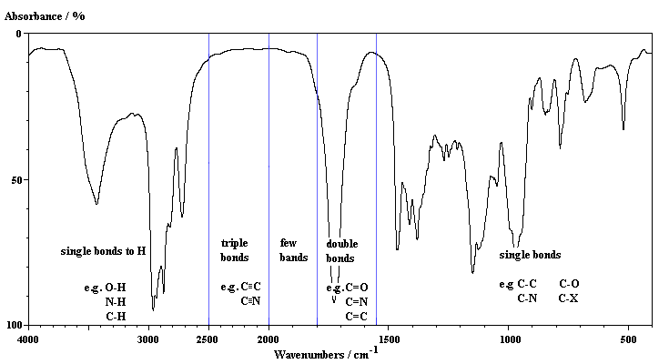

Figure 1: Simplified IR Absorptions

In this experiment you will be given an unknown sample and take its IR spectrum in order to determine the chemical structure based on the functional group(s) present. The identity of your unknown is one of the compounds in Table 1, below.

Table 1: List of Possible Unknowns

|  |  |
| --- | --- |
| Acetic acid | Methanol |
| Anisole | Methyl acetate |
| Benzaldehyde | Methylamine |
| Benzonitrile | Methylethylketone |
| Dimethylformamide | Nitromethane |

**How to obtain an IR spectrum:**

Before running the instrument take a moment to familiarize yourself with its layout. In this instrument there is the sample area with a small pedestal where the sample will go. On/in that pedestal is a small inorganic crystal through which the infrared light that will be used to measure your sample is emitted. On the pedestal should be a screw off ‘top’ with a conical hole in the middle, through which the crystal can be seen. This conical hole is where the liquid sample will be placed.

**Setting up the program** – *done by instructor*

1. Open the OMNIC program

2. Under experiment, use the drop down menu to select ATR.

3. Click experiment setup.

* Select %transmittance, select to collect background before every sample, then click ok

**Running the sample** – *done by student*

1. Click **collect sample**, *but don’t add your sample yet!*

2. Enter the file name as the last names of all group members and the unknown number

* (e.g. onorato_russell_126)

3. A window will pop up that says “need background”. Make sure the instrument is closed and click **ok**.

* This will take 32 scans (the count is in the bottom left hand corner)

4. Once the background is done, add 1 drop of the unknown to the IR crystal, close the cover and click **ok**.

* This will also take 32 scans

5. Once the spectrum is collected, a window will pop up saying “add to window”. **Click yes**

6. Click **find peaks** and adjust the threshold so that the major peaks are identified with their corresponding wavenumber.

7. Click **replace original spectrum** button and say **yes**.

8. Go to file and print spectrum (select Direct Printer).

9. Click the **clear** button above the spectrum to remove your spectrum for the next group (*make sure it prints first*)

10. Clean the IR crystal - Screw off the liquid sample holder and *gently* wipe it down with acetone or ethanol and a Kim wipe. *Gently*wipe down the crystal embedded in the pedestal and allow the acetone/ethanol to evaporate off. Once clean, screw the liquid sample top back into place

**Do not close the window or exit the software until the end of lab!** Otherwise the experiment set up will revert back to default.

**Hazards**

Although only small amounts will be used, avoid inhalation and skin contact, as some unknowns can be toxic. Eye protection and gloves are required. Waste must be disposed of properly.

**Infrared Spectroscopy**

|  |  |  |  |  |
| --- | --- | --- | --- | --- |
| **Name:** |  |  | **Section:** |  |

|  |  |
| --- | --- |
| **Unknown number:** |  |

**Unknown Structure** *(use chemical drawing software; must be electronically pasted into the word document)*

List the significant peaks in your IR Spectrum in the table below.

|  |  |
| --- | --- |
| $$\tilde{v}, {\text{cm}}^{\text{-1}}$$ | Functional Group |
|  |  |
|  |  |
|  |  |
|  |  |
|  |  |
|  |  |

Attach the IR spectrum of your unknown. Draw the structure of your unknown directly on the spectrum. Label the major peaks that correspond to the functional groups within the molecule. *You do not need to label every peak within the spectra.*

**Questions**

1. You will find the IR spectra of compounds A-E on the website, each with their own unique molecular formula. Draw a structure consistent with each IR spectrum directly on the spectrum. Label the major peaks that correspond to the functional groups within the molecule. *You do not need to label every peak within the spectra.*

2. Explain how you can use IR to distinguish between the following pairs of compounds.

|  |  |
| --- | --- |
| a) |  |
| b) |  |
| c) |  |
| d) |  |