Subject: Social Studies
Topic: Underground Railroad
Grade Level: Kindergarten
Lesson Length: 1 hour

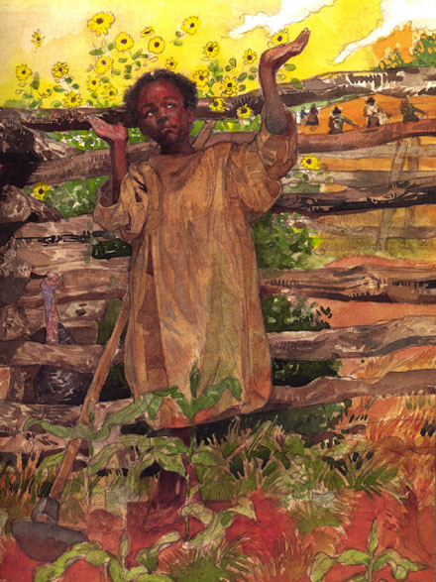
Objective: The students will learn about Harriet Tubman and her role in the Underground Railroad movement. The students will compare themselves to Harriet Tubman in the book Minty using a Venn diagram.

Materials:
-Minty “A Story of the Young Harriet Tubman” by Alan Shroeder
-A picture of Harriet Tubman
-Venn Diagram
-Index cards of characteristics of Minty and children of today.
-Map of Ohio River
-Sunflower coloring sheet (Minty pretended to be a sunflower) Illustrated by Jerry Pinkney “Minty A Story of Harriet Tubman”

Procedures:
- Review with the students what they learned about the Underground Railroad. Show a picture of the Ohio River and discuss the route to freedom.
- Show the students the book, Minty. Have the students make predictions about the book using what they have learned about the Underground Railroad. Then take a picture walk. After their picture walk explain to the students that this story is about a brave lady who had a big part in helping free hundreds of slaves. Then show them a picture of Harriet Tubman as an adult and then again the cover of Minty. Explain to the students that Minty is Harriet Tubman as a young girl.
- Tell the students to listen to the story about for things in the story that are alike or different from them. Read the story Minty to the students.
- Students will use a Venn diagram to compare their lives to Minty’s. Each child will be given an index card with a characteristic on it. We will read the card aloud and each student will place their characteristic in the correct spot.
- The students will color a sunflower and will dictate to the teacher something they remembered from the story.

Resources:
Websites:
http/www.lhric.org/pocantico/tubman/tubman.html
www.undergroundrailroad.org

Assessments
- Class participation
- Teacher observation
- Student colored sunflower with a dictation of something they remembered from the story.
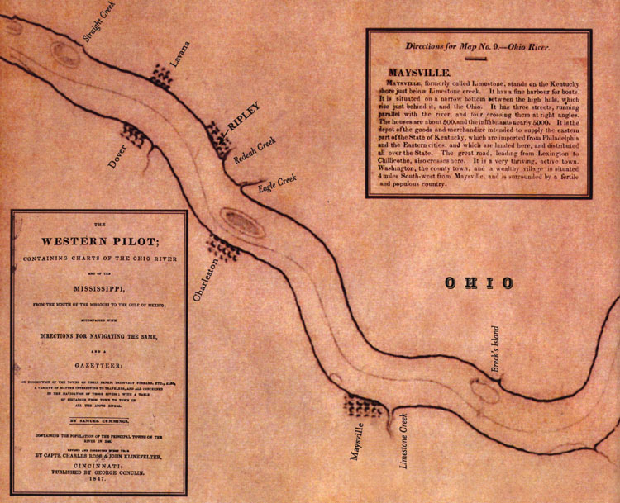

Illustration from” Freedom River” by Doreen Rappaport

