Name: Kara McNabb Lesson Length: 3 days (1hr each)
Grade Level: 2nd Subject: Social Studies Topic: Underground Rail Road

Objectives:
Students will identify and define the importance of the Underground Railroad.

Connections: This lesson fits the following Kentucky Learner Goals:

1.2 Students make sense of the variety of materials they read
1.14 Students make sense of ideas and communicate ideas with music
2.14 Students understand the democratic principles of justice, equality, responsibility, and freedom and apply them to real-life situations.

Materials/Technology:
Book: Walking the Road to Freedom
Poster board for each group
Markers/crayons
Pencils
Lined paper

Procedures:
Interest catch:
1) Read the book Walking the Road to Freedom (A story about Sojourner Truth) to the class.
2) Discuss the events that happened in the story.
3.)Students get into groups of two. Number the students 1 and 2 until all students are numbered and divide group.
4.) The groups make a timeline of Sojourner Truth’s life according to the book.
5.)Students will write a paragraph about why their group thinks that Sojourner Truth was brave in helping the slaves escape to freedom.
6.) Students will share their timeline and paragraph with their peers.
Closure: Discuss the Underground Railroad and how Sojourner Truth contributed to the Underground Railroad.
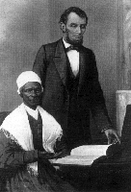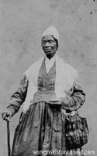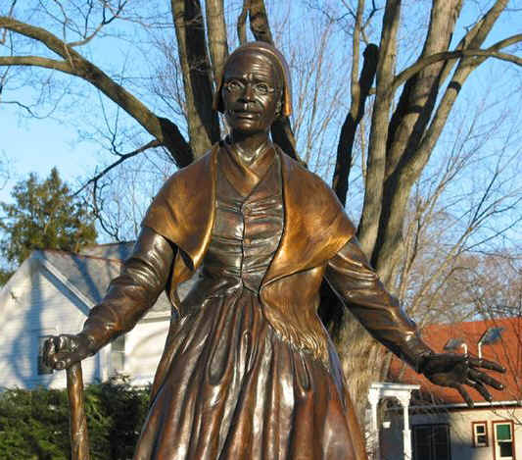

Websites:
http://www.geocities.com/Athens/Oracle/9840/sojourn.html
http://womenshistory.about.com/library/bio/bltruth.htm
http://library.thinkquest.org/10320/Truth.htm
http://www.noho.com/sojourner/

Student Assessment:
Observation: Observe if students are actively participating in class discussion and activities.
Work samples: Students complete timeline and paragraph, assess for understanding.

Day 2

Materials:
Book: Follow The Drinking Gourd
picture of the constellation, the Big Dipper
gourd
Computer with internet access
Procedures:
Have you ever looked at the sky? Do you think you could follow a star to get you somewhere?
Show the children a picture of the constellation, the Big Dipper, and point out its relationship to the North Star. Discuss if students have ever noticed this constellation in the sky.
Show the students the gourd and discuss how you would make it into a dipper for water.
Read the story Follow the Drinking Gourd to the students.
Students will visit http://www.madison.k12.wi.us/planetarium/ftdg1.htm to teach the meaning of each verse of the song.
Have some of the students act out the words as some of the other students read the words.
Give the students a copy of the words, sing the song together.

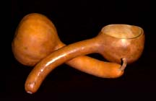

Assessment:
Observation: Observe if students are actively participating in class discussion and activities.

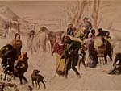
Day 3
Materials:
Paper
Pencils
(graphic organizer if needed)

Procedures:
Ask the students to imagine how a slave might have felt.
1) Have each student brainstorm about the feelings that a slave may have felt. Students may use an organizer.
2) Ask the students how a slave might have felt while traveling through the Underground Railroad (afraid, worried). Give the students two minutes to brainstorm about this.
3) Students need to brainstorm for two minutes about how they might have felt when they hit freedom (free, safe and happy).
4.)Students will write a story using the writing prompt: My trip to freedom, to write a story of how they may have felt if they were a slave on their journey to freedom.
5.)Students will share their story with their peers.

Assessment:
Work Samples: Students will write a story showing they understand the emotion/feelings the slaves may have felt during the Underground Railroad.
Student Assessment: Students will fill out a star chart stating how they felt about their learning of the Underground Railroad.

