The Underground Railroad: Geography and History
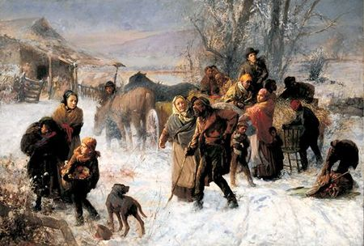http://news.enquirer.com/apps/pbcs.dll/article?AID=/AB/20060917/ENT07/609170320/
Charles T. Webber's "The Underground Railroad" c.1893 located at the Cincinnati Art Museum
Subject: Social Studies Major Content: Geography and History Age/Grade Level: 9-10
Lesson Length: Three Days (50 minute periods)
Miranda Ward
Context
Learning about the geography of the Southern United States and the history of the Underground Railroad is integral for students to completely comprehend what many slaves faced when they ran away. Students are familiar with the geography of the south and have learned about the Underground Railroad in the past, so the focus of this unit will be to make their knowledge more concrete and to put a name with the areas, landforms, and climate of the southern U.S and to dispel the myths associated with the Underground Railroad. Another focus will be to connect their previous knowledge of the geography of the south with the decisions fugitive slaves had to make if they chose to run. The lessons in this unit are meant to be used as building blocks to help students learn about the courage, determination, and heroism associated with the Underground Railroad. Student involvement is necessary for this unit. Students must contribute, think critically, use previous knowledge, and work with their peers to make decisions.

Objectives
- Students will be able to define vocabulary and laws associated with the Underground Railroad.
- Students will be able to apply their knowledge of the Underground Railroad to discover personal characteristics of the people involved in the movement.
- Students will be able to name and locate on a map of the U.S. the various sub-regions and physical features located in the Southern United States with eighty percent accuracy.
- Students will be able to explain how the physical features of the southern Untied States may have played a role in an enslaved person’s decision to run away.
- Students will be able to explain how the physical features of the southern United States helped or hindered fugitive slaves during their escape.
- Students will describe the push and pull factors associated with an enslaved person’s decision to attempt escaping.
- Students will be able to analyze their personal characteristics in order to compare themselves to abolitionists and will discuss the importance of helping others.

Connections
Objective 1 and 2: Goal 2.20 – Students understand, analyze, and interpret historical events, conditions, trends, and issues to develop historical perspective.
Objective 3, 4, 5, and 6: Goal 2.19 – Students recognize and understand the relationship between people and geography and apply their knowledge to real-life situations.
Objective 4 and 5: SS-HS-4.2.2 - Students will explain how physical (e.g., climate, mountains, rivers) and human characteristics (e.g., interstate highways, urban centers, workforce) of regions create advantages and disadvantages for human activities in a specific place.
Objective 6: SS-HS-4.3.1 - Students will describe the movement and settlement patterns of people in various places and analyze the causes of the movement and settlement (e.g., push factors such as famines or military conflicts; pull factors such as climate or economic opportunity) and the impacts in the modern world (1500 A.D. to present) and United States (Reconstruction to present). Note: Although this is pre-Reconstruction U.S. Geography, the concepts of push factors and pull factors are still being taught to students.
Objective 7: Goal 3.6 – Demonstrate ability to make decisions on ethical values.

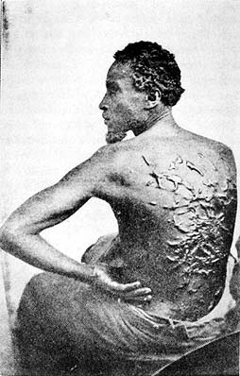
http://historymatters.gmu.edu/d/6808
Photo of a former slave who suffered from being severely beaten

Assessment Plan

Learner Objective Number | Type of Assessment | Description of  Assessment | Adaptations and/or Accomodations
Objective 1 | Formative | Define terms and laws on Vocabulary Code Worksheet | Rephrase
Objective 2 | Formative | Writing Activity where students summarize their thoughts of the people who participated in the Underground Railroad | Rephrase
Objective 3 | Formative | Label a map with sub-regions and physical features | Rephrase
Objective 4 | Formative | Small Group Discussion of physical features and their connection to the UGRR. Worksheet and Journal Entry | Rephrase
Objective 5 | Formative | Small Group Discussion of physical features and their connection to the UGRR. Worksheet and Journal Entry | Rephrase
Objective 6 | Formative | Small Group Discussion of push and pull factors in connection to the UGRR. Worksheet and Journal Entry | Rephrase
Objective 7 | Formative | Journal Entry | Rephrase

Resources, media, and technology
- Vocabulary Code Worksheet
- Selected passages from His Promised Land: The Autobiography of John P. Parker, Former Slave and Conductor on the Underground Railroad (I suggest page 25 paragraph 2 to the bottom of page 27, page 73 paragraph 3 and 4, page 87 paragraph 2, page 99 paragraph 5, chapter 11 page 118 to page 121.)
- Map of Underground Railroad Routes from http://www.safepassageohio.org/resources/Lesson4.pdf
- Map of Underground Railroad Routes from http://education.ucdavis.edu/NEW/STC/lesson/socstud/railroad/images/map2.gif
- The Class text World Geography Today. Written by Prof. David M. Helgren and Prof. Robert J. Sager. Published by Holt, Rinehart and Winston, Austin, 2000.
- Worksheet for small group activity.
- Outline for notes

Procedures
Day One
- Introduce the unit using the vocabulary code worksheet. It is meant to be a fun activity, but is also informative. Give students time to think about the definitions of the words, then provide the actual definitions to the class (10-15 minutes).
- Open the discussion with passages from His Promised Land: The Autobiography of John P. Parker, Former Slave and Conductor on the Underground Railroad. The basis of the activity is provide background information about the Underground Railroad and to facilitate a discussion regarding why slaves chose to run away, the dangers they faced along the way, the dangers that abolitionists faced when they helped fugitive slaves, and finally, the personal characteristics of the people who were passengers, conductors, and agents on the Underground Railroad.
- Wrap up the lesson by asking students to summarize the discussion in one paragraph in their journals and to focus on one of the following characteristics that are descriptive of participants of the Underground Railroad to describe the fugitive slaves and abolitionists: heroic, brave, sacrificial, determined or creative.

Day Two
- Introduce the topics of the lesson to students by asking them about the physical geography of the South and what they know about the Underground Railroad.
- Provide handout to students for the Small Group Activity and put one of the maps of the Underground Railroad routes up using the overhead projector. Explain the activity. Be sure to remind students of the importance of physical features and needs that the fugitive slaves will face when they escape (e.g. mountains, rivers, climate, and food).
- After both groups have chosen their four slaves, we will have a time of discussion. Each group must justify their decisions. We will compare the decisions of the two groups.
- To wrap up the lesson, have students write a paragraph in their journals that describes what slaves had to consider before making the decision to run away and have the students state what it would take for them to run if they were in a similar situation.

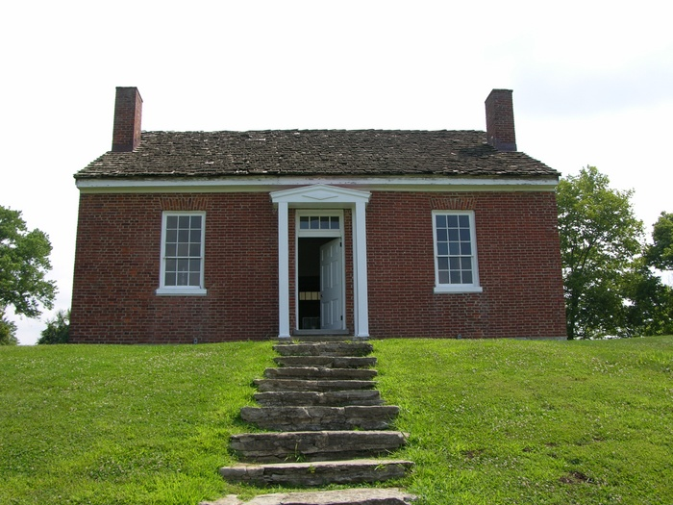
http://www.voydanoff.net/gallery/Underground-Railroad-Ripley%2C-Ohio?page=1
Photo of the front of Rev. John Rankin’s home in Ripley, Ohio.

Day Three
- Introduce the topics of the lesson to students by reading the passage about Eliza from His Promised Land (page 123 paragraph 1 to page 125 paragraph 3).
- Provide an outline for notes to the class. Included on the outline should be information about Rev. John Rankin and his family, Levi Coffin, John P. Parker, Harriet Beecher Stowe, and information on the Ohio River.
- The next portion of the class should be used to discuss local history and to bring a personal understanding of the risks that abolitionists faced and the personal characteristics of the abolitionists to the students. The questions should also help to promote moral education while still covering content. Ask the following questions to the class: What role did the Ohio River play in fugitive slaves quests for freedom? Why was it necessary for there to be strong groups of abolitionists along the Ohio River? What risks did these abolitionists take by helping fugitive slaves? Why do you believe the abolitionists took those risks? Would you be willing to take those risks to help someone in need of assistance? If you were living during that period in U.S. history, what would it take for you to help a fugitive slave? What would it take for you to avoid helping a fugitive slave?
- To wrap up the lesson, have the students write their final journal entry for the unit. In one paragraph answer the following questions: do your present actions represent how you would have reacted in a situation where you could either help a fugitive slave or turn them away? In your life, how do you view helping others? Is it necessary or do you believe it to be unnecessary? Provide examples to support your views.

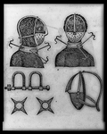
http://lcweb2.loc.gov/cgi-bin/query/r?pp/PPALL:@field(DOCID+@lit(98504457))
Various forms of restraint devices used on enslaved people.

Vocabulary Code Worksheet

Below is a list of vocabulary words for the unit. In Column A, write what you believe is the definition of the word. You will fill in the actual definition in Column B when we go over the worksheet as a class.

Column A Column B
1. Dry Goods ______________________ _______________________
2. Hardware ______________________ _______________________
3. Depot or Terminal ______________________ _______________________
4. Conductor ______________________ _______________________
5. River Jordan ______________________ _______________________
6. Grand Central Station ______________________ _______________________
7. Canaan ______________________ _______________________
8. Midnight ______________________ _______________________
9. Passenger ______________________ _______________________
10. Package ______________________ _______________________
11. Agent ______________________ _______________________
12. Drinking Gourd ______________________ _______________________
13. Three-Fifths Compromise ______________________ _______________________
______________________ _______________________
______________________ _______________________
14. Fugitive Slave Law, 1850 ______________________ _______________________
______________________ _______________________
______________________ _______________________
http://www.safepassageohio.org/resources/Lesson4.pdf

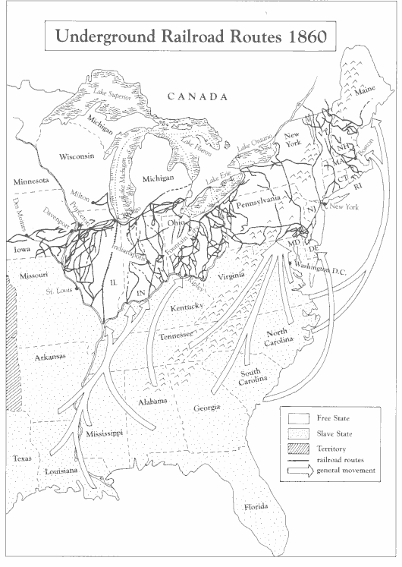
http://education.ucdavis.edu/NEW/STC/lesson/socstud/railroad/Map.htm

Worksheet for Small Group Activity Name:__________________________
Class Period: ____________________

The year is 1852. You are in northern Alabama where many slaves are being oppressed. Local abolitionists have arranged for 4 enslaved people to escape in order to make their way to Canada. Below is a list of slaves who are willing to make the journey. You and your group members must decide who gets to escape. As a group choose 4, and only 4, people to make the escape. Individually, write your group’s decisions below and provide justification for each person in at least two sentences and include geographical features that helped your group make each decision.

- An elderly woman who has never seen her grandchildren who live in Canada.
- A young man who is beaten at least once a week.
- A young woman who is married (to number 4) but lives on a different plantation than her husband. They have a child (number 5) who is about to be sold to a man from New Orleans, Louisiana.
- A young man who is married (to number 3) but lives on a different plantation than his wife. They have a child (number 5) who is about to be sold to a man from New Orleans, Louisiana.
- A 5-year-old boy who is about to be sold to a man from New Orleans, Louisiana. He will be separated from his parents (number 3 and number 4) in the process.
- A woman in her twenties who is abused by her master and has no family.
- A 15-year-old boy who is very ill, but could be cured if he makes it to Canada.
- A 9-year-old girl who was sold when she was 6. Her parents have since earned their freedom, and they have been searching for her. Due to local hostilities, they were forced to move to Ohio. If the little girl makes it to Ohio, she will be reunited with her family.
- A 32-year-old man who is strong, healthy, and good-looking.

The Final Four
1. ____________________________________________________________________________
Justification-___________________________________________________________________
______________________________________________________________________________
______________________________________________________________________________
2. ____________________________________________________________________________
Justification-___________________________________________________________________
______________________________________________________________________________
______________________________________________________________________________
3. ____________________________________________________________________________
Justification-___________________________________________________________________
______________________________________________________________________________
______________________________________________________________________________
4. ____________________________________________________________________________
Justification-___________________________________________________________________
______________________________________________________________________________
______________________________________________________________________________

Outline for Notes

- The Ohio River
  - Width and Depth ___________________________________________________
_________________________________________________________________
  - Borderland ________________________________________________________
__________________________________________________________________
  - River Jordan

- Local Abolitionists
  - Rev. John Rankin and Family _________________________________________
__________________________________________________________________
__________________________________________________________________
  - Levi Coffin ________________________________________________________
__________________________________________________________________
__________________________________________________________________
  - John P. Parker _____________________________________________________
__________________________________________________________________
__________________________________________________________________
  - Harriet Beecher Stowe _______________________________________________
__________________________________________________________________
__________________________________________________________________

