Name: Melinda Boesken Kim Crable
Grade: Third Grade
Subject: Underground Railroad
Major Content: Social Studies Lesson Length: 40 Minutes

Goals and Objectives:

The students will be able to describe the concept of slavery.

The students will obtain background knowledge of the Northern and Southern regions.

Prior Knowledge: (This will be done prior to the beginning of the lesson)

Teacher will lead a discussion of quilting in colonial times. Students will be shown a quilt. They will look at how it is stitched together. We will talk about where the material came from. Ask the question: Do you think a quilt could save someone’s life? Read A Quilt Full of Memories.

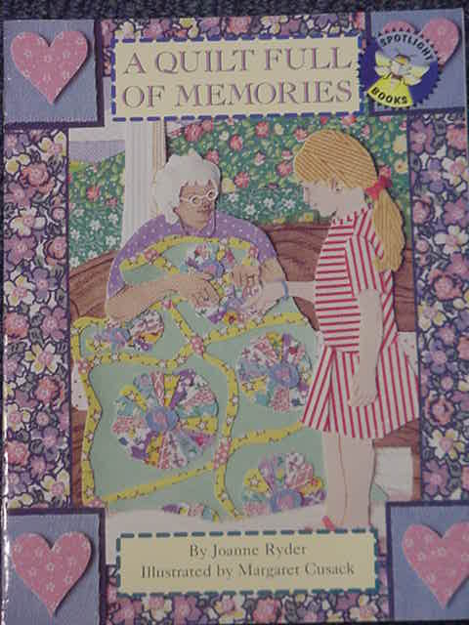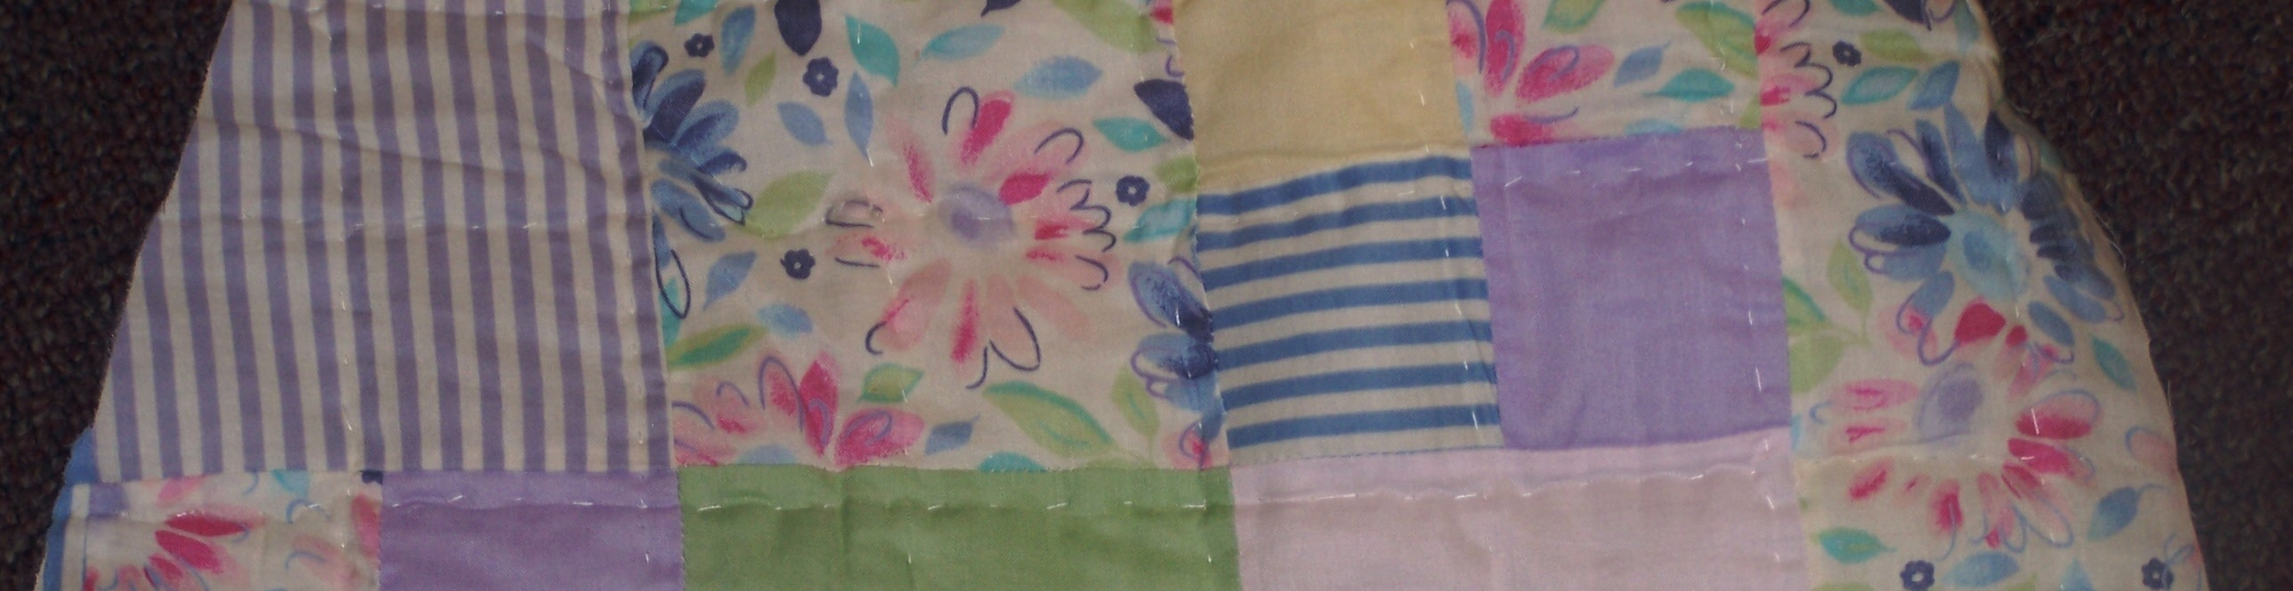
Connections:

SS-EP-4.2.1

Context:

This is the second day of the lesson. We have previously discussed maps and how they are useful. Students have background knowledge of slavery and quilting. Share from the (Scholastic) book, if You Lived When There Was Slavery in America.

Materials/Technology:

Map of the United States

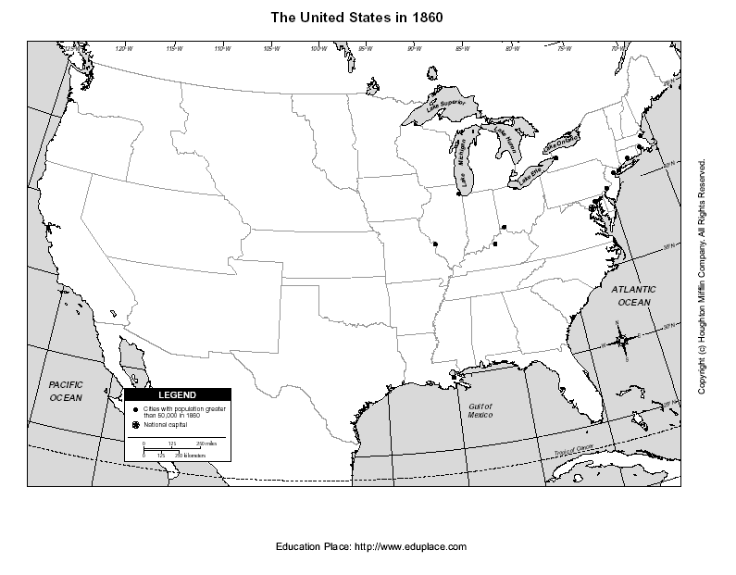
KWL Chart

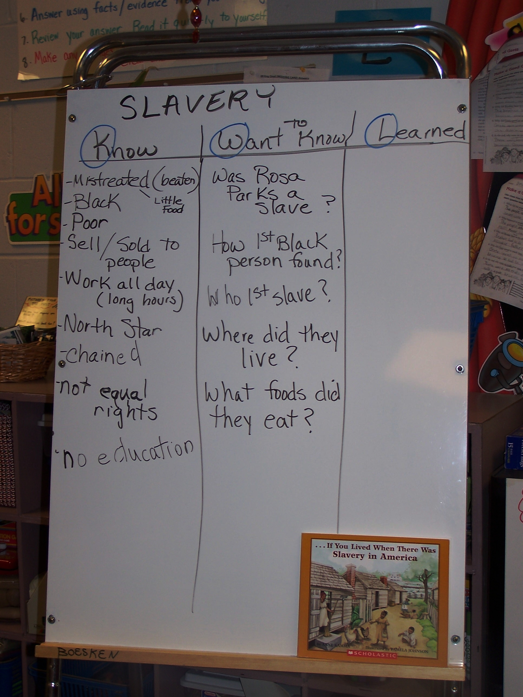

Procedures:

- Using a KWL chart ask: What do you know about slavery?
- Using a map of the United States, show the land in the South (why was it used?) and look at climate and vegetation.
- Explain how the North was mostly factories and they didn’t need enslaved people.
- Show the Ohio River and explain how it was narrow and shallow at that time. Explain it was the boundary that separated the North and South.
- Begin a discussion by asking: Do you think many children were separated from their parents and ask why this happened. (emotional detachment). Why did they need enslaved people to work the fields? (economic focus).
- Ask: What do you want to know about slavery? (KWL Chart)

Assessment:

Formative: Questioning/Class participation
Discussion

Summative: Journal reaction: Reflect on these questions in your journal.

A) Explain which region (North or South) felt the need for slavery and explain why.

B). Imagine the hottest day of the summer. You are forced to stay outside all day mowing grass, pulling weeds, and raking. All you have is one slice of bread and one bottle of water. The other children on your street are inside watching T.V. How would you feel? Is there anything you could do to make you feel less desperate?

Day 3

Goals and Objectives:

Students will illustrate how the Underground Railroad helped enslaved people escape north to freedom.

Students will summarize how enslaved people used other methods to assist in their escape. (quilts, North Star)

Connections:

SS -EP-2.2.1

Context:

This is the third day of our unit. Our goal today is to introduce the Underground Railroad and other means used to help the enslaved people escape North. Students will begin to understand why enslaved people had no maps and relied on others to escape.

Materials/Technology:

Vocabulary Cards
Sweet Clara and the Freedom Quilt by Deborah Hopkinson

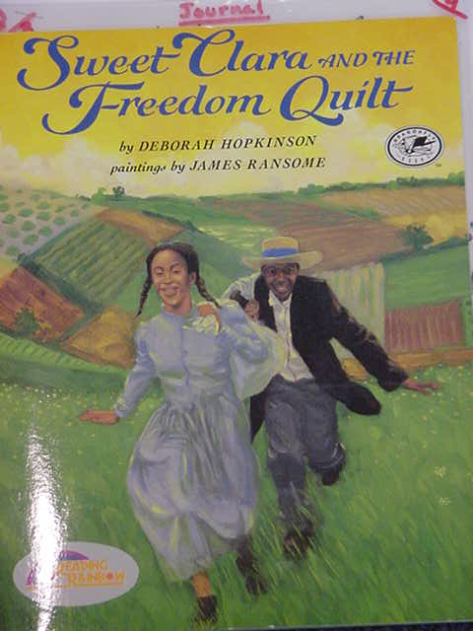

Procedures:

- Review several responses from their journal activity from day one.
- Ask students how they would escape if they were a slave. Explain the harsh consequences to enslaved people if they were caught trying to escape.
- Introduction of book. Ask students if they have ever used a map and how it helped them. What special symbols did they observe? How would they use a map? Ask what kinds of information they can find on a map. Make a word web to record their answers.
4) Introduce vocabulary words:

Plantation Missus
Underground Railroad Field Hand
Big House
Quarters Guide
Overseer Skirting
Master Banks

5) Explain to the students that this is an example of historical fiction.

- Explain that the author uses dialect to give the book an authentic feel of how the people on a plantation really talked.

- Begin reading the first part of the book (pp. 4-19). Ask the following questions:

Why did Aunt Rachel not want Clara to run away?

What is the Underground Railroad?

Why don’t you think more enslaved people used maps to escape? (didn’t have access, had no idea what was beyond the plantation)

What are some reasons Clara chose to make her map on a quilt? What might you use besides a quilt to make a map?

Day 4

Goals and Objectives:

The students will understand how the Underground Railroad helped enslaved people escape north to freedom and that they used various methods to assist them.

Connections:

SS – EP – 2.2.1

Context:

Maps were primitive and the enslaved people had to use their imagination to escape. They had to be courageous and believe in themselves and there were abolitionists to help at times.

Materials/Technology:

Sweet Clara and the Freedom Quilt

Photographs from local history (Rankin, Parker and Bierbower houses)

Procedures:

- Review the Underground Railroad. Explain why it is important to know the directions North, South, East and West. Ask what have you learned about maps that would be important for Clara to know.

- Read the second half of the book (pp.20-33). Identify how people gave clues to Clara discreetly to help her in making the quilt. Why do you think that none of the enslaved people talk about the map/quilt directly? Why do you think the boat and star were the last pieces she put on the quilt? Why is it important that Clara leave the quilt behind? Explain your answer.

- Show pictures from local history to make this seem more real. Tell students that our local history was important to the UGRR. For example: discuss John Parker and John Rankin and show pictures of their homes on the poster board.

Assessment:

Formative: Questioning
Discussion of part two of book

Summative: Finish the KWL chart. Ask,What have you learned?

**Journal writing activity:**

What do you think Clara meant when she said, “Sometimes I wish I could sew a quilt that would spread over the whole land?”

How does Clara’s life change when she overhears the drivers talking to Cook about the Ohio River?

Do you think that Clara is a heroine? Explain your answer.

Imagine you are a white person living in the south during slavery. You and your friends own a plantation and have many enslaved people. You think slavery is wrong. Would you be a part of the URR and what things would you do to help the enslaved people?

Final Day

Sweet Clara and the Freedom Quilt

Culminating Activities:

Each student will contribute individually to creating a quilt that will tell about what is important to them. Each student will make his or her own square. Show the students an example of a quilt. Explain that instead of using fabric, we will use markers, colored pencils, crayons or colored paper. Each student will decide on his/her own scene or idea. When they have finished their individual “squares”, we will display them on a hall or class bulletin board.

View the video titled “American History for Children: African Americans”

Extension:

Take students to the computer lab and visit the National Geographic.com site and go to the Underground Railroad link.

