Length _1 1/2 wks Age/Grade Level 9th
Subject Language Arts
Major Content His Promised Land Topic/Title Literary Understanding of Slavery

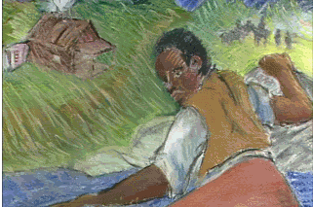

Actions:

Goals and Objectives:

-Students will create a diorama based on their chapter of His Promised Land identifying Parker’s hardships when escaping to freedom and helping other fugitives to escape to freedom.
-Students will be able to describe the emotional and physical loss (family, belongings, personal identity, etc.) due to slavery. Students will also be able to discuss the hardships that came with John Parker’s life (loss of family, emotional/physical struggles etc.) and how fugitive slaves escaped. Students will evaluate their chapter read and write a summary to discuss with the class.
-Students will reflect upon John Parker’s life (how he grew up, his travels to be free, the bravery it took to be free and help other slaves to be free, his determination) and make connections with their own lives (what it would be like to be separated from your parents and chained, traveling alone hoping to not get caught, helping others to be freed of slavery – risking your own life and property, going days without eating) .

Connections:

    - Make connections among literature, students’ lives, and/or real world issues.
AE goal: 1.2 Make sense of a variety of material they read.
1.11 Students write using appropriate forms, conventions, and styles to
communicate ideas and information to different audiences for different purposes.
2.22 Students create works of art and make presentations to convey a point of view.
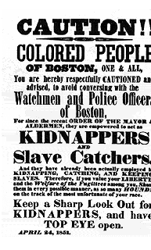
Resources:

His Promised Land, edited by: Stuart Steely Sprague
Paper
Writing utensil
His Promised Land broken up into chapters
Diorama rubric

Procedures:

After showing a power point of the Underground Railroad and discussing and lecturing to make sure the students have background knowledge of the Underground Railroad, Students will read the preface, and original introduction from His Promised Land as a class.

Students will be paired up with one other student in the class and then be given the assignment.

-Each pair will be given one chapter from the book to read.
-Students will be given the rubric for the diorama and reflection

Explain that students will be reading their assigned chapter, creating a diorama that represents something from that chapter, writing a reflection about their chapter, and then presenting their diorama to the class along with a summary of their chapter.
(longer chapters such as one and ten can be given to the more gifted students to differentiate)

The teacher should go over the rubric, reflection, and summary to make sure all students understand what is expected of them. Questions?

If there aren’t any questions, have the students begin reading their chapter silently.

If students finish before the end of class, have them begin brainstorming their diorama and what they need to bring in tomorrow to create their diorama. If students do not finish reading their chapter, they can finish it for homework, brainstorm their diorama, and contact their partner in the evening to decide what to bring in tomorrow.
(If students aren’t ready to work on their diorama on day two, they can work on their reflection and/or their summary.)

Students will have four days to work on their diorama, reflection, and summary in class.

Day 6, students will begin presenting their dioramas beginning with chapter one. This may take two or three days.

Student Assessment:

Students will be graded based on their performance noted in the rubric. (attached)

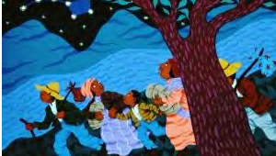

Diorama

His Promised Land

CATEGORY | 10 | 8 | 6 | 5 or lower
Use of Class Time | Used time well during each class period. Focused on getting the project done. Never distracted others. | Used time well during each class period. Usually focused on getting the project done and never distracted others. | Used some of the time well during each class period. There was some focus on getting the project done but occasionally distracted others. | Did not use class time to focus on the project OR often distracted others.
Content - Accuracy | At least 7 accurate facts are displayed in the summary. AND/OR  The summary flows without reader confusion. | 5-6 accurate facts are displayed in the summary. AND/OR The summary has some confusion for the reader, but it’s still coherent. | 3-4 accurate facts are displayed in the summary. AND/OR The summary is confusing and the reader needs more info to understand. | Less than 3 accurate facts are displayed in the summary. AND/OR the summary is NOT coherent.
Reflection | Student can accurately reflect upon and relate to the chapter readings.  1 or fewer grammar mistakes. (1 pg)  /15 | Student can accurately reflect upon and relate to the chapter readings. 3 or few grammar mistakes. (3/4 pg)  /13 | Student can reflect upon and relate to the chapter readings. 6 or fewer grammar mistakes  (1/2 - 3/4 pg)  /11 | Student can reflect or relate to the chapter readings. 6 or more grammar mistakes  (1/2 pg or less)  /10
Originality  (Chapter/Title marked) | The diorama shows an exceptional degree of student creativity in the project | Diorama shows student creativity in the project | The diorama is made by the student, but based off others designs | No parts of the diorama are made by the student (computer created)
Grammar | There are 1 or fewer grammatical mistakes on the diorama or summary. | There are 3 or fewer grammatical mistakes on the diorama or summary. | There are 6 or fewer grammatical mistakes on the diorama or summary. | There is more than 6 grammatical mistakes diorama or summary.
Attractiveness | The poster is exceptionally attractive in terms of design, layout, and neatness. | The poster is attractive in terms of design, layout and neatness. | The poster is acceptably attractive though it may be a bit messy. | The poster is distractingly messy or very poorly designed. It is not attractive.
Presentation | Shows a full understanding of the topic and is able to accurately answer almost all questions posed by classmates about the topic. | Shows a good understanding of the topic and is able to accurately answer most questions posed by classmates about the topic. | Shows a good understanding of parts of the topic and is able to accurately answer a few questions posed by classmates. | Does not seem to understand the topic very well and is unable to accurately answer questions.

