Larry Hutzel 3 days
9th grade
English 9 Underground Railroad
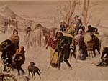

Objectives:
The students will be introduced to the Underground Railroad and will be able to define, interpret, and describe its impact to U.S. History.

Materials/Technology:
Computer lab, Underground Railroad notes, musical compact disc, DVD, library books

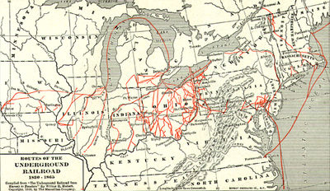

Procedures:
Day 1:

- Students will respond to the following prompt:
What do you currently think of when you hear the Underground Railroad? What comes to mind? What images do you picture? Explain everything you know or believe about the Underground Railroad. (15 min.)
- Class discussion of writing prompt. (10-15 min.)
- Students will perform a wikipedia web search for the Underground Railroad and the
class will read and discuss the information provided. (15 min.)
- Students will continue Underground Railroad web searches to learn more about the
topic. The students will focus on websites provider by the instructor. (45 min.)

Day 2:

- Students will view the video clips from the KET’s Underground Railroad Video
Segments web page.
http://www.ket.org/underground/resources/segments01.htm 
(45 min.)

- Students will preview a collection of Underground Railroad related library books.
(45 min.)

Day 3:

- Students will read aloud and discuss the following slave stories:

Box Brown at http://www.spartacus.schoolnet.co.uk/USASbox.htm

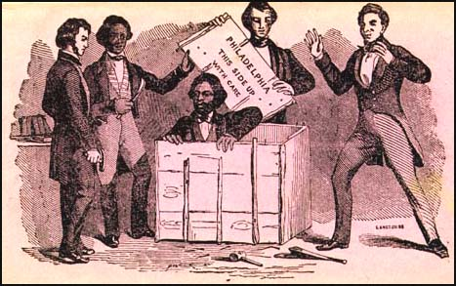

and

Margaret Garner at http://www.rootsweb.com/~kypendle/slavemargaretgarner.htm

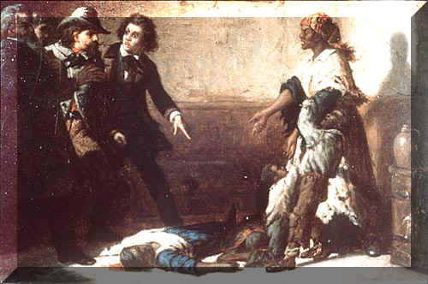

(60 min.)
- Students will begin work on their project options, which include the following: (30 min.)
1) Write a persuasive letter in protest against or in defense of slavery to a powerful government official as one of the following:
- Free black
- Runaway enslaved person
- Slave owner
2) Write up an advertisement for a slave auction or a will including the passing of a slave as property
3) Write a 3 poems or songs about the Underground Railroad
4) Create a short children’s book telling the story of either Box Brown or
Margaret Garner
5) Create a diorama about one scene from the one of the stories: Box Brown or
Margaret Garner

Student Assessment:
Students assessment will be measured through their journal entries and their
projects.

Impact - Reflection/Analysis of Teaching and Learning-
The overall objective was to introduce students to the Underground Railroad and
provide them with a basic understanding of its existence and purpose. That
education was clearly established and recognized through class discussions,
questions from and to the students and the level of interest and enthusiasm
exhibited in the topic.
Underground Railroad Websites

http://www.pbs.org/wgbh/aia/part4/4p2944.html

http://en.wikipedia.org/wiki/underground_railroad

http://www.pocanticohills.org/tubman/tubman.html

http://209.10.16.21/template/FrontEnd/index.cfm

http://www.spartacus.schoolnet.co.uk/USAunderground.htm

http://www.waynet.org/nonprofit/coffin.htm

http://www.rootsweb.com/~kypendle/slavemargaretgarner.htm

http://www.history.rochester.edu/class/ugrr/home.html

http://www.cr.nps.gov/aahistory/ugrr/ugrr.htm

http://www.greece.k12.ny.us/ath/library/webquests/underground/default.htm#task_resources

http://www.ushistory.com/railr.htm

http://www.undergroundrr.com/

http://www.ket.org/underground/resources/segments01.htm

https://www.evndirect.com/shopping/product_details.php/id=116

