Subject: Language Arts/Social Studies
Topic: Harriet Tubman
Grade Level: First Grade
Lesson Length: 45 minutes (6 days)

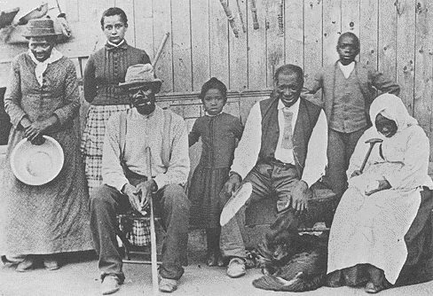
Objectives:
The students will listen and recall important facts and details from the book, The Value of Helping, The Story of Harriet Tubman, by Ann Donegan Johnson.

The students will be able to discuss the life of Harriet Tubman was and how she helped others throughout her life time.

The students will write and illustrate different periods and events of Harriet Tubman’s life that they obtained from the book, The Value of Helping, The Story of Harriet Tubman, by Ann Donegan Johnson.

The students will explain by writing and illustrating how they could help someone.

Connections:
RD-EP-2.0 Developing an initial understanding
RD-EP-3.0 Interpreting text
RD-EP-4.0 Reflecting and responding to text
WR-E-1.1.00 Purpose/Audience: students will establish and maintain a focused purpose to communicate with an authentic audience by narrowing the topic to present an idea
WR-EP-1.2.00 Idea Development/Support: develop logical, justified, and suitable explanations; explaining related connections or reflections
SS-EP-2.1 Culture is the way of life shared by a group of people, including their ideas and traditions. Culture influences viewpoints, social rules, and social institutions.
SS-EP-5.1 History is the interpretation of events, people, ideas, and their interaction over time.

Materials:
Book: The Value of Helping, The Story of Harriet Tubman, by Ann Donegan Johnson
Pre-made Harriet Tubman student writing journal
Pencils
Crayons
Pre-made star made out of white construction paper
Chart paper
Markers
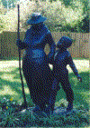

Procedures:
Teacher will need to provide background knowledge of the time period and geographical locations prior to lessons.

Day 1-5
Students will be called to whole group setting. Students will listen to a read aloud from the book, The Value of Helping, The Story of Harriet Tubman (pages 1-20). Throughout the read aloud and class discussion, students will make predictions about the story, gain an understanding of Harriet Tubman, and how she helped others during that time period of her life. The teacher will use chart paper to record information of Harriet Tubman during the group discussion. After the reading, the students will return to their seats. They will then illustrate and write in their Harriet Tubman Journal about how Harriet helped others during that time period in her life. Students will complete this activity and return to a whole group setting and share their writing.
Continue this procedure daily but follow the designated pages from the book for each day.

Day 2 –Pages 21-29
Day 3 –Pages 30-39
Day 4 –Pages 40-51
Day 5 –Pages 51-62

Day 6 Procedures:
Students will be called to a whole group setting.
Review and discuss information learned about Harriet Tubman throughout the lessons. Have Students choose their favorite way Harriet Tubman helped others.
The students will be given a pre-made star like the character Twinkle, from the book The Value of Helping, The Story of Harriet Tubman. The students will return to their seats. They will illustrate and write on the star how they could help someone and make a difference in their lives. The students will complete this activity and return to a whole group setting and share their “Helping Star”. Display students “Helping Stars”.
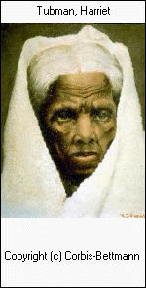

Assessment:
- Participation-observation-discussion
- Completion of Harriet Tubman Journal
- Completion of The Helping Star

Extension:
Have the students create a timeline of their own life.

Resources:
Websites: http://americancivilwar.com/women/harriet_tubman.html
http://www.amicaslibrary.gov/cgi-bin/page.cgi//aa/tubman
http://www.math.buffalo.edu/~sww/0history/hwny-tubman.html
http://www.touraburnny.com/tubman/html
http://www.kwdpl.org/wihohio/tub-har.html

Books: Donegan Johnson, Ann. 1979. The Value of Helping, The Story of Harriet Tubman. La Jolla, CA: Value Communications, INC.

