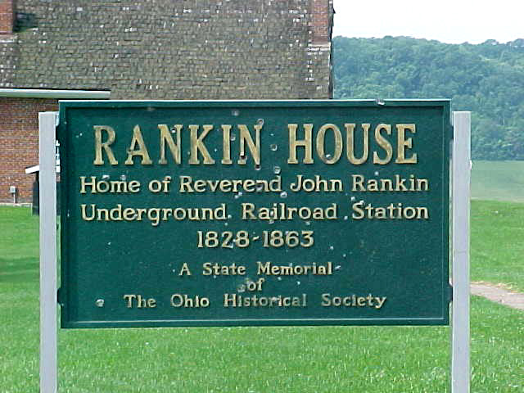
The Under- Round Railroad System

Subject: History Grade 2
Unit Title: Underground Railroad Each lesson about 45 minutes long

Goal:
-Students will compare the freedoms Americans have today to the lack of freedom enslaved people had during the time of the Underground Railroad.

-Students will create a quilt square demonstrating their knowledge of the Underground Railroad.

- -Students will be able to describe Harriet Tubman.

-Students will create an escape story.

Objective:
The students will find factual information about the Underground Railroad System.

CONNECTIONS

Core Content

SS-EP-5.2.1
Students will identify significant patriotic and historical songs, symbols, monuments/landmarks (e.g., The Star-Spangled Banner, the Underground Railroad, the Statue of Liberty) and patriotic holidays (e.g., Veteran’s Day, Martin Luther King’s birthday, Fourth of July) and explain their historical significance.

SS-05-5.2.2
Students will explain reasons (e.g., freedoms, opportunities, fleeing negative situations) immigrants came to America long ago (Colonization and Settlement, Industrialization and Immigration, Twentieth Century to Present) and compare with why immigrants come to America today.

Kentucky Learner Goals:
2.20 Students understand, analyze, and interpret historical events, conditions, trends, and issues to develop historical perspective.

Context
Students have already read for information this year. These lessons will build/review on student’s prior knowledge for informational reading. We have also talked about the freedoms we have in America, so we will build on this looking from a then and know perspective.

Resources
- Journal
- Sweet Clara and the Freedom Quilt book
- KWL Chart
- Paper for Poster
- Magazines
- Glue
- Crayons/Pencil
- Venn Diagram Paper
- Final Assessment Sheet
- Minty: A Story of Young Harriet Tubman book
- Construction paper(star)
- Star outs
- Construction pieces for quilt
- The Drinking Gourd book
- List of web sites for students

Procedures:

DAY 1

- I will begin class by activating student’s prior knowledge on the Underground Railroad by doing a KWL chart.

- We will discuss how freedoms are different know for African Americans then and know.

- Each child will make a poster showing what freedoms they have today.

- Each child will share their posters and make a chart of all the reasons they love America.

DAY 2

- Introduce the term, Underground Railroad. Talk about how people who try to run away to reach freedom. Discuss what they would do and how they would do it. Tell them about the secret codes and let them guess what they mean.

6. Read Minty: A Story of Young Harriet Tubman

- Have the students create a north star to their dreams for the future. On the center of the star they will write their dream and on each point, a way to achieve that dream.

DAY 3

- Open class by reviewing KWL chart and adding things if needed.

- Read Sweet Clara and the Freedom Quilt

- Have the students create their own secret map to freedom. They will take
different pieces of construction paper and write their plan of escape on each piece. First piece will be home and the last piece will be freedom. This will also be an assessment to see if they understand what we have covered so far.

*Show students the web site http://www.beavton.k12.or.us/Greenwat/leahy/ugrr/index.htm
This is a web site that shows a virtual Underground Railroad quilt. As students finish they will be free to use class computer to surf the web with web-sites given on the Underground Railroad.

DAY 4

We will continue the freedom quilts. As they are working I will talk about some of the terms and facts that I learned this summer in facts. I will help the students understand the meaning of the freedom quilt and how important their freedom is. What would it be like to be Clara; to be separated from your parents, family and friends? As they finish they will present their quilts to the class.

DAY 5

- Write a journal response stating how you would feel if you were separated from your family to escape freedom.
*Scared
*Nervous
*Happy
*Sad
*Etc.

- Read The Drinking Gourd

- Assessment
With a partner plan a plan of escape. I will have a sheet made up and the students will have to pick one person/item from each category:
*Character
*A Friend Who Helps
*Hiding Place
*Danger
*Resource
*Discomfort
*Mode of Travel

Student Assessment

- I will have a pre-written rubric sheet that I will have typed up and graded them accordingly at the end of the unit on their escape story.

- I will have the student assess each other according to my pre-made rubric
to see how their peers see their work.

Impact
I feel that these lessons made for a very successful unit. My students had little or no prior knowledge of the Underground Railroad. They were very attentive and seemed to really enjoy the lesson. As we would review the prior day’s discussions, they knew all the information. Even my students that struggle with re-telling were so interested in what we were studying that I was able to see a different side of their comprehension.

Refinement
The next time I teach this lesson I think I will spend a little more time building background knowledge for my students on the Underground Railroad. They did great, but I feel at times some assessments were a little difficult for them because most of them had never even heard the term, Underground Railroad. The quilt activity was a little confusing for them. I will need to create my own quilt before hand so that they will know what I am expecting from them.

Additional Web sites
http://www.ugrr.org
http://www.beavton.k12.or.us/Greenway/leahy/ugrr/index.htm.
http://artsci.wustl.edu/~educ/historyweb/
http://www.pbs.org/wgbh/aia/part4/4p2944.html

