Harriet Tubman
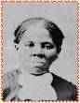

and the
Underground Railroad

Name: Carrie Skirvin
Subject: Social Studies and Language Arts
Topic: Harriet Tubman and the Underground Railroad
Age/Grade Level: Kindergarten
Lesson Length: 4 days (45 minutes each day)
Objective:
- The student will be able to describe Harriet Tubman as an enslaved person and a hero.
- The student will be aware of the importance of the Ohio River to the Underground Railroad movement.
- The student will demonstrate information learned about Harriet Tubman and the Underground Railroad by completing an exit slip.
Connections:
1.4 Students make sense of the various messages to which they listen. Students understand the democratic principles of justice, equality, responsibility, and freedom and apply them to real-life situations.
2.20 Students understand, analyze, and interpret historical events, conditions, trends, and issues to develop historical perspective.
6.2 Students use what they already know to acquire new knowledge, develop new skills, or interpret new experiences.
Context:
This week long mini-unit on Harriet Tubman and the Underground Railroad provides the kindergartners with an introduction to slavery. Later in the year, units on Martin Luther King, Jr. and other famous African Americans will be completed. The Underground Railroad unit will give students the background knowledge to better understand our history.
Materials:
-Harriet Tubman by Catherine Nichols
-“On An Underground Railroad” by Kinny Landrum -(http://www.ushistory.com/railr.htm#problems)
-Harriet Tubman silhouettes
-Candle
-Computer
-Cloze procedure for “On An Underground Railroad”
-Barefoot: Escape on the Underground Railroad by Pamela Edwards
-Map
-Parent/principal permission to walk to Ohio River
-Underground Railroad exit slip
-Props for bounty hunter/slave tag (Kentucky symbol, Ohio symbol, Ohio River symbol, poster board candles, bounty hunter symbol)
-blank tape
-tape recorder
Procedures:
Day One:
-Greet students with candle burning in the classroom window. Teacher will greet each student saying, “A friend of a friend.”
-Throughout the day, allow students to experience inequality (treat boys and girls differently).
-Find out prior knowledge of Harriet Tubman.
-Read Harriet Tubman by Catherine Nichols to show how a black person was treated as a slave. The story will also show the jobs of a slave.
-Respond to Harriet Tubman. Small groups will be given a large silhouette of young Harriet Tubman. Small groups will draw pictures to represent information learned about Harriet Tubman’s life. While students are working introduce music to “On An Underground Railroad” by Kinny Landrum (http://www.ushistory.com/railr.htm#problems).
-Small groups will share artwork.

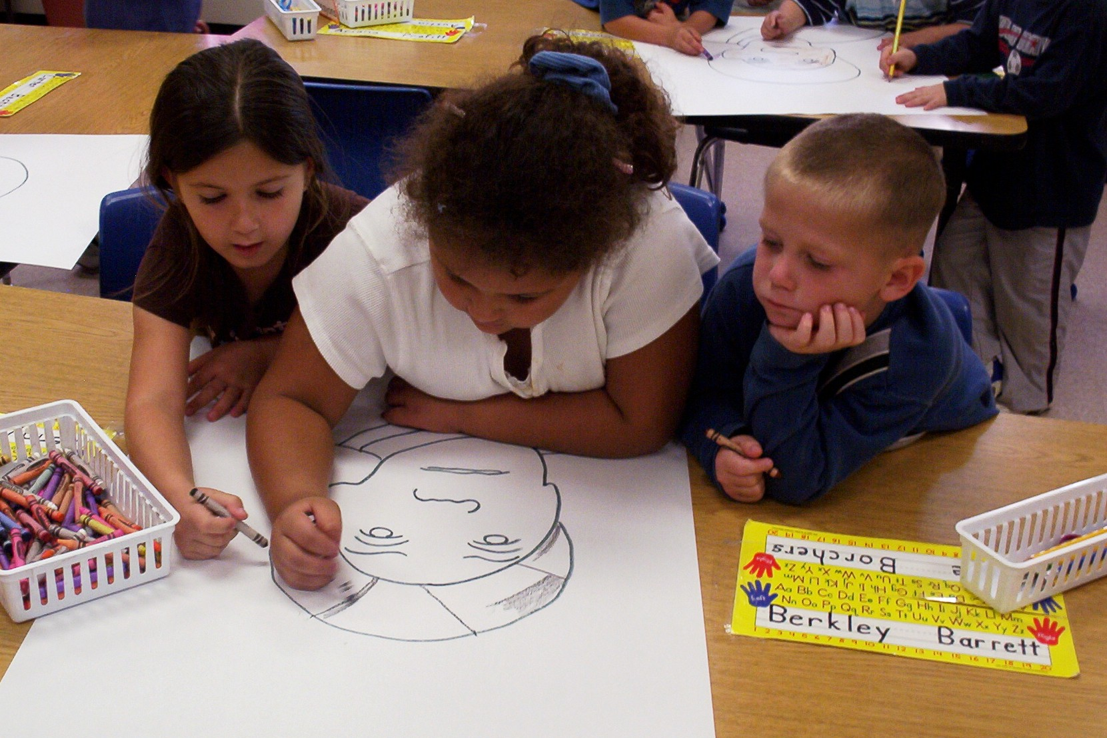

Day Two:
-Review information learned about Harriet Tubman (refer to silhouettes).
-Tell students Harriet Tubman was a real-life hero on the Underground Railroad. What was the Underground Railroad?
-Watch music video “On An Underground Railroad” (http://www.ushistory.com/railr.htm#problems).
-Focus on the words to the song using the cloze procedure. The lyrics explain the Underground Railroad.

Day Three:
-Review with “On An Underground Railroad” music video.
-Ask questions about the Underground Railroad (who, what, where, when, and why).
-Read Barefoot: Escape on the Underground Railroad by Pamela Edwards.
-Use map to show slaves journey to freedom. Introduce safe houses (explain the lighted candles and “A Friend of a Friend” greeting).
-Share the importance of the Ohio River.
-Reenact a slave’s journey from the south across the Ohio River.
-Play bounty hunter/slave tag. Students will pretend to be slaves trying to escape freedom and the bounty hunter in game one. In game two, the students will again pretend to be slaves trying to escape freedom and the bounty hunter, but this time the slaves are safe if they are standing on a poster board candle (safe house).
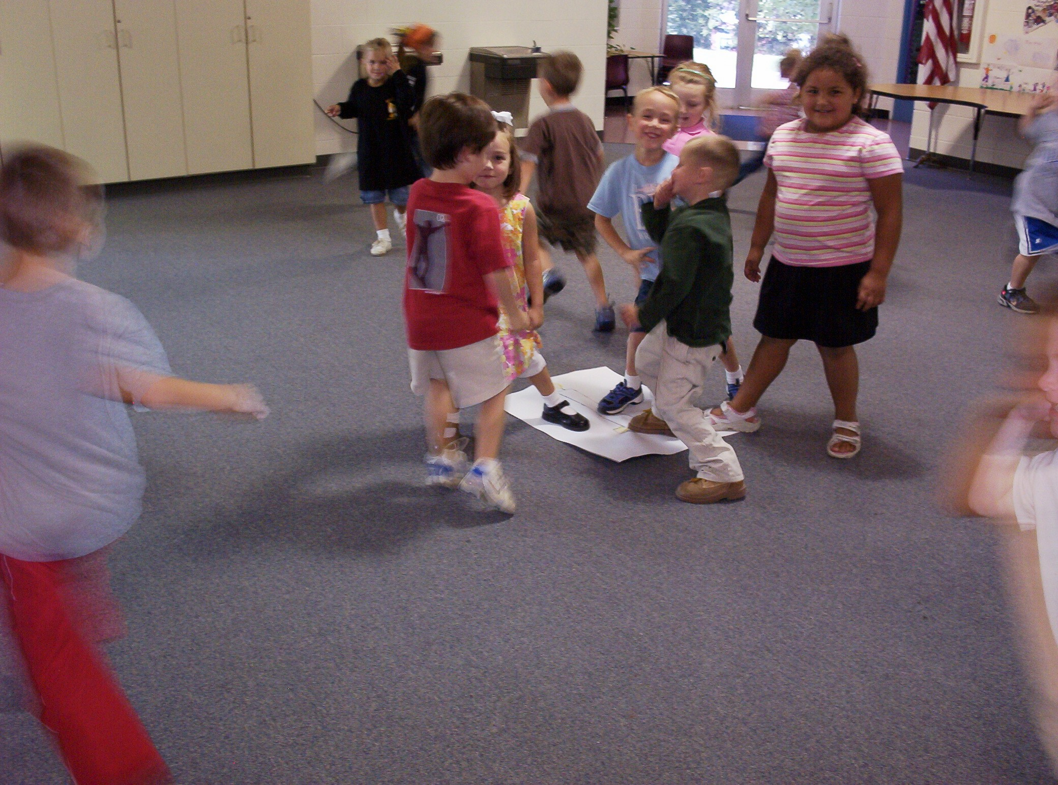

Day Four:
-Record Mrs. Skirvin’s class version of “On An Underground Railroad” with the help of third graders that also learning about the Underground Railroad.
-Review the importance of the Ohio River to the Underground Railroad.
-Experience the Ohio River. Walk to the river to show first hand a slaves journey.
-Complete an exit slip based on the Underground Railroad.

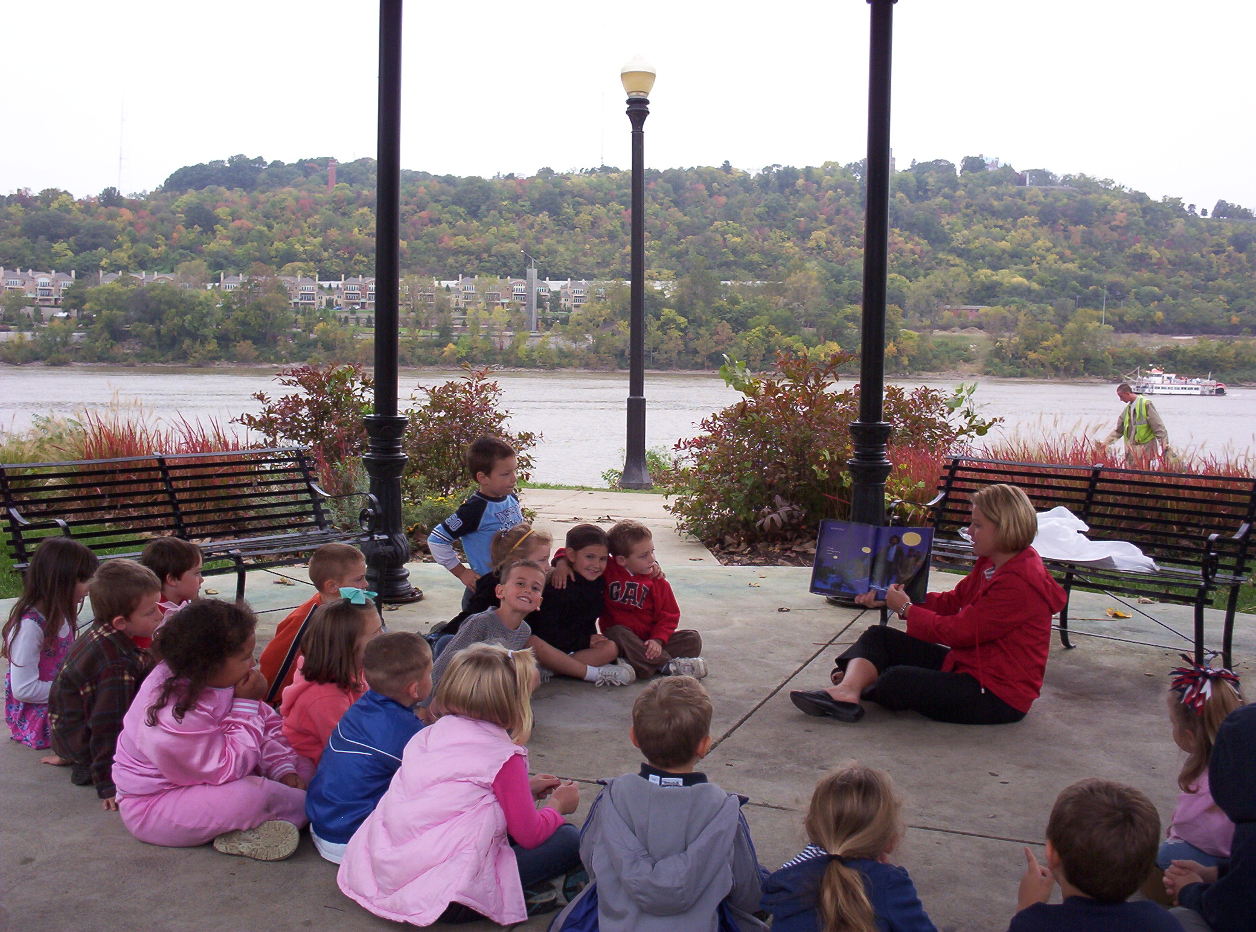

Assessment:
- Class participation
- Teacher observation
- Completion of Underground Railroad exit slip

