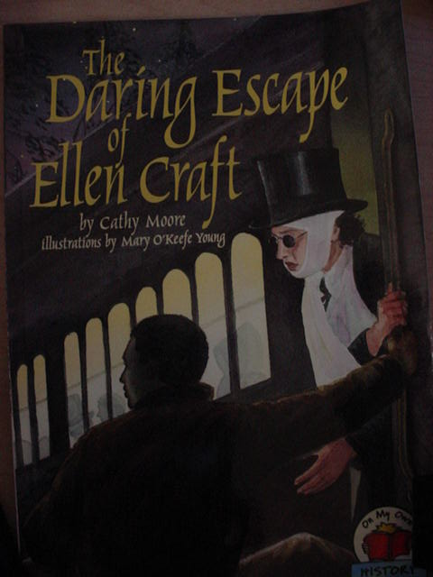

Title: Can You Be Tricked?
Subject: Art/Special Education
Name: Molly Uchtman and Kathryn Whitledge
Grade Level: Second Grade
Lesson Length: Four Thirty Minute Sessions

Objectives:
The students will be able to describe the escape of William and Ellen Craft through the storybook The Daring Escape of Ellen Craft. The student's will create a self-portrait. The student's will disguise their self-portrait.

Connections:
1.3 Students make sense of the various things they observe.
1.4 Students make sense of the various messages to which they listen.
1.13 Students make sense of ideas and communicate ideas with the visual arts.
2.14 Students understand the democratic principles of justice, equality, responsibility, and
freedom and apply them to real-life situations.
2.16 Students observe, analyze, and interpret human behaviors, social groupings, and
institutions to better understand people and the relationships among individuals and
among groups of our nation and world.
2.19 Students recognize and understand the relationship between people and geography
and apply their knowledge in real-life situations.
2.20 Students understand, analyze, and interpret historical events, conditions, trends, and
issues to develop historical perspective.
5.2 Students use creative thinking skills to develop or invent novel, constructive ideas or
products.
6.1 Students connect knowledge and experiences from different subject areas.
6.2 Students use what they already know to acquire new knowledge, develop new skills,
or interpret new experiences.

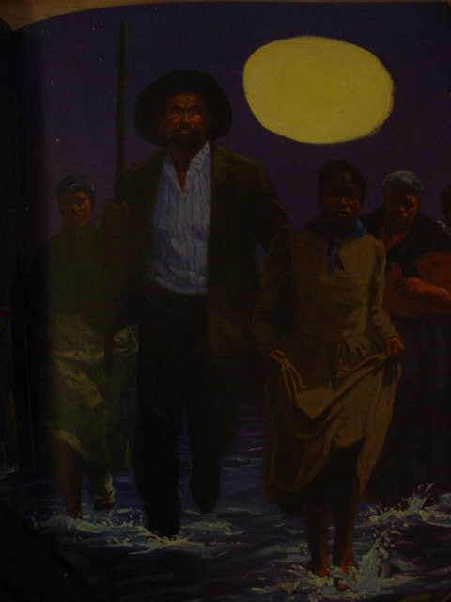

Context:
This lesson will serve as an introduction to the Underground Railroad. Through the use of art, technology, children’s literature, and a writing assignment, students will learn about why enslaved people attempted to escape and the assistance they received along the way to hide from bounty hunters. The children’s book The Daring Escape of Ellen Craft helps to introduce the children of the plight of the runaways and helps to introduce the need for clever disguises. A self-portrait that students disguise helps them to put themselves in the place of an escaping runaway. The writing activity will be used as way of reflecting on what they have learned. Modifications for students with learning disabilities will be provided as directed by individual education plans.

Materials/Technology:
- The Daring Escape of Ellen Craft
- Portrait PowerPoint
- Drawing Paper
- Pencil, Crayons, Erasers
- Multi-cultural crayons
- Disguise PowerPoint
- Disguise materials
- Glue
- Scissors (Adapted scissors will be available as needed)

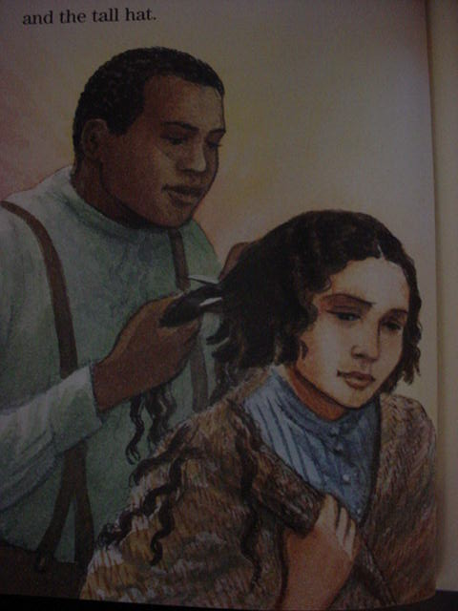

Procedures:
Day 1
- The students will be introduced to the term portrait and the procedure for drawing a proportional portrait through a PowerPoint.
- The students will add details and correct colors to their self-portrait.
Day 2
- A map will be shown to students so that they can better understand the distance and paths taken to freedom.
- A teacher led discussion will include the reasons that enslaved people tried to escape and the lengths that they had to go to in order to keep from being captured (i.e. traveling at night, hiding in the daylight hours, wearing disguises, etc.).
- The Craft book will be read to the students and a discussion about the Craft's disguise and the Underground Railroad will follow.
Day 3
- The students will watch the disguise PowerPoint and try to determine who is hidden behind the disguise.
- The students will discuss what a disguise is and why people wear them.
- Using various materials the students will create a disguise for their self-portrait.
Day 4
- The students will write about their disguise, using the modified worksheet as needed.
- Portraits will be on display as students take turns reading the descriptions they have written about their disguises. Other students will try to identify the correct self portrait.
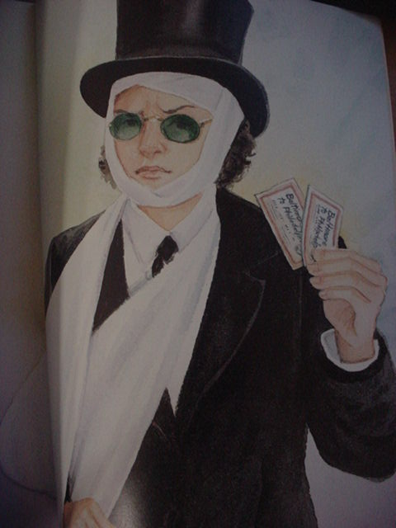

Student Assessment:
Students will be assessed using the attached rubric. The goal for each student is to draw a self-portrait with correct features and proportions, make an attempt to disguise the features that they have drawn, and write a description about how they disguised their face. Students receiving special education services will be assisted using the attached modified worksheet.

Beginning | Progressing | Proficient | Distinguished
An attempt was made at completing a portrait and/or writing piece. | 1 out of 3 criteria has been successfully completed | 2 out of 3 of the criteria have been successfully met. | All of the following criteria has been met:  - Portrait has correct features and proportions;  - An attempt is made to disguise features;  - Writing piece corresponds with the portrait.

This accommodations page will help meet the needs of most children requiring special education services. There is enough space to write for those with fine motor issues. Words and picture clues are provided for non-readers. Text is simplified for low level readers. Space is available at the bottom for those capable of copying a provided text. The page can be enlarged for those that are visually impaired.

