Visions of Freedom

I am a slave, wishing for freedom.
Far in the distance I feel that I am free.
My hands are weary with prickly thorns as I quickly walk up the path.
My feet are sore because I own no shoes.
My back is aching because I was whipped.
I feel hatred toward those who have and brag about freedom.
The vision of freedom forms in my head.

I am a slave, wishing for freedom.
Far in the distance the smell of happiness tickles my nose.
My shoulder carries the fresh scent of blood.
I think something has gone wrong with my dinner, or it is poisoned.
Out on the mountain it smells like fresh pine needles.
I smell Mistress’s perfume…. She is going to the chapel.
The vision of freedom forms in my head.

I am a slave, wishing for freedom.
Far in the distance I see a cardinal, flying quickly to her babies.
A bobcat cub bats at a butterfly floating in the air.
I look unhappily at the wild flowers, growing freely.
Inside my head I see a vision of freedom and escape.
The vision of freedom forms in my head.

I am a slave, wishing for freedom.
Far in the distance I hear a wolf howl in hunger….Harooo!
I listen to the gentle hum of the wind.
My head relaxes when the birds chirp out their shrill melody.
On the sides of my head my ears take in a melody that rocks me to sleep.
I hear freedom in Canada calling my name.
“Come to Canada, Jasmine! Come to Canada and be free!”
The vision of freedom forms in my head.

ESCAPING FROM SLAVERY

Escaping the plantation I hear dogs barking and gunshots
ringing as other slaves and me escape.
We hear dreadful cries of innocent slaves as furious
voices rise above the treetops saying, “Catch them, catch them!”
I hope we don’t get caught.
As we escape the plantation and rush into the barren woods
darkness falls upon us.
I wish we would make it to the Promised Land.

Escaping the plantation we scramble quickly through the treacherous woods.
We see several safe houses ahead.
As we rapidly knock on the door we secretly say the code
“Friend of a friend.”
Now we know this house is safe.
I wish we would make it to the Promised Land.

Escaping the plantation we wait for dinner in the safe house.
The delicious aroma from the kitchen drifts to us.
With satisfied stomachs we scramble outside moving on through our journey.
Tired and swollen… our barren skin feels ragged just like our clothes.
I wish we would make it to the Promised Land.

Escaping the plantation we are at the Promised Land!
Sick smelling dirt soaks our clothes
We are finally there… The Promised Land!
Joy bursts out like a rainbow,
Arching with its color and happiness.
We are at the Promised Land!

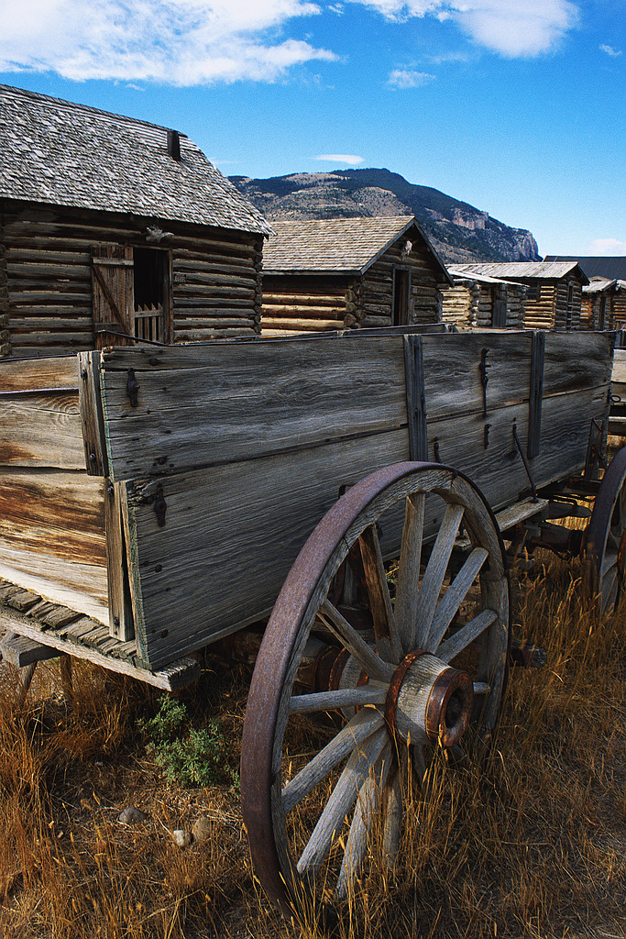

OH SLAVERY

Oh slavery! I glance at a large, gray coyote on a rocky hill by the long Ohio River.
The slave catchers ride their brown horses quickly toward me.
I jump across the cold ice floes in an almost straight line to escape them.
I see the slave catchers on the other side of the Jordan River.
I need to get to the promise land.

Oh slavery! I feel the hard, cold ground and the wet, green grass.
I sense the large, cold ice floes on my bare feet.
My hand barely holding onto the ice, my now wet feet in the cold river.
I feel the mud and slick rocks.
I brush against the leaves and low trees.
I need to get to the promise land.

Oh slavery! I smell pumpkin pie baking in the safe house stove.
The candles brightly shining on the window sill.
Then the next day I smell the fresh, morning air.
As I ride the freedom wagon. I smell an aroma of flowers.
The flowers smell like blueberry pie.
I need to get to the promise land.

Oh slavery! The slave catchers yelling “Come back!” Bang! Bang! go the small guns.
My feet step on the green grass.
I listen to beautiful songs of the Underground Railroad.
In the safe house I hear slaves talking loudly.
I listen to the bushes loudly rustle as more slaves arrive.
The next day we arrived at the promise land.
I’m finally at the Promised Land!

On My Way To Canada

Please don’t take me away from my family!
I glance to my right seeing butterflies dancing freely as I walk in
shackles to my new house where I will work.
Swat, swat my hand hits the butterflies.
Why are they free when I’m not?
Slavery is a cruel thing, I’m glad they abolished it.

Please don’t take me away from my family!
“You can’t escape!”cried my friend Amy.
“I have to” I declared.
“And I want you to come with me.”
We will leave tonight.
Rustle, rustle I hear the leaves crunch under Amy’s
and my feet as we run through the forest feeling the wind
whipping my face as we run to a safe house.
Slavery is a cruel thing, I’m glad they abolished it.

Please don’t take me away from my family!
“We’re almost to Canada!” I whisper to Amy.
“I know!” She whispers back.
Tomorrow night we’ll go to Canada and meet
our families their. It’s almost morning we better
go to sleep. I sniff the scent of bread and
close my eyes.
Slavery is a cruel thing, I’m glad they abolished it.

Please don’t take me away from my family!
The next night, we will thank the
family and head for Canada.
We are only a few feet away from Canada
when we hear dogs barking.
“Run” I say.
We run to the cottage our families are staying in.
“We finally are free.”
I say to Amy.
Slavery is a cruel thing, I’m glad they abolished it.
.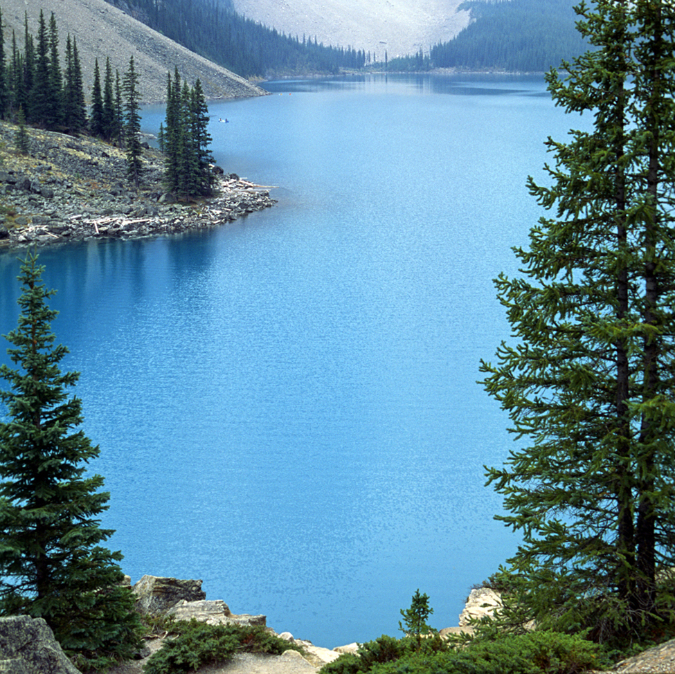
THE WAY TO FREEDOM!

On my way to freedom I see the free flowers, the fluttering brown moths.
I hear the moaning slaves as they pick the soft cotton.
I wait till midnight when my master is fast asleep.
I tell my family “Goodbye”.
Then I begin my journey to the Promised Land.
Rest and safety for the tired traveler.
Rest and safety for the hungry wanderers.

On my way to freedom I swiftly run through the treacherous woods.
I hear the deadly blood hounds “Harrow”!
I hear gun shots “Bam bam”!
I am afraid they will catch me and beat me with their
leather whips, and wooden sticks.
I search for wild onions to rub on me.
So the dogs cannot follow.
Rest and safety for the tired traveler.
Rest and safety for the hungry wanderers.

On my way to freedom I feel tired, hungry, and fearful.
I look for a safe house where I will be offered food, a soft bed, and safety.
I spy flickering candles in a window of a house close by.
I scamper like a horrified rabbit toward the dim light.
Rest and safety for the tired traveler.
Rest and safety for the hungry wanderers.

On my way to freedom I see the Jordon River
dividing the north from the south.
A skiff is lying on the shore
I quietly crawl into it and franticly row.
Rain falls on my face.
It washes my sweat off my face.
I see the Promised Land.
Rest and safety for the tired traveler.
Rest and safety for the hungry wanderers.

