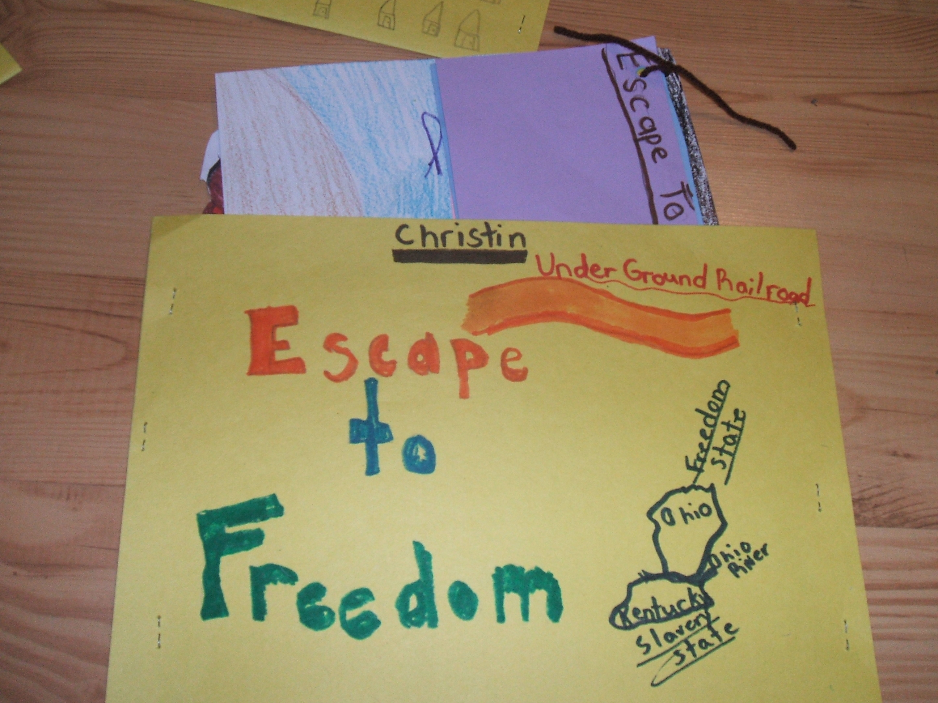
ESCAPE TO FREEDOM:
A JOURNEY ALONG THE Underground railroad
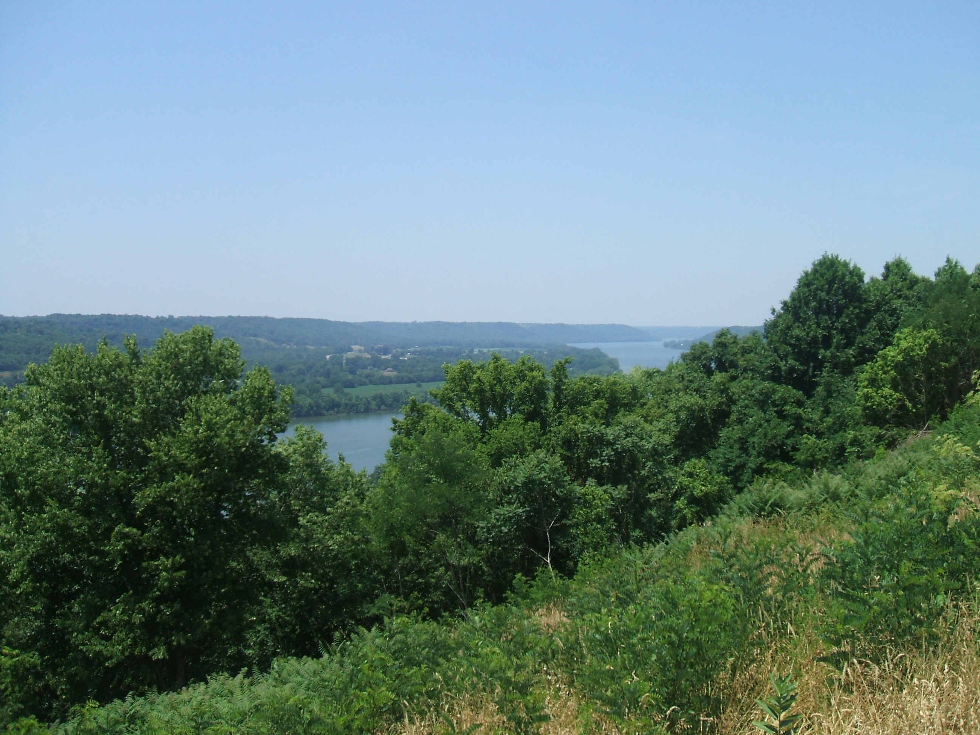
Created by: Janice Banks
EDU 594
Summer 2007
This 4 day mini-unit allows students to experience the injustices of some enslaved people. The lessons were developed so students could discover the importance of every day slave life during the 1800’s and the decisions that enslaved people faced before and during their escape to freedom along the Underground Railroad. Some of the famous people studied included: Minty (young Harriet Tubman); Henry Box Brown; Eliza; and Ellen and William Craft.
ESCAPE TO FREEDOM: Lesson Plan

Janice Banks 4—45 minute session
3rd grade
Social Studies

Objectives:
Students will be able to describe the every day life of slaves.
Students will learn about the physical and emotional treatment that slaves’ received.
Students will learn how some slaves used their resourcefulness to escape to freedom.

Connections:
Kentucky Learner Goals:
Reading: 1.3 Students make sense of the variety of materials they observe.
1.4 Students make sense of the various messages to which they listen.
1.11 Students write using appropriate forms, conventions, and styles to communicate ideas and information to different audiences for different purposes.
Social Studies: 2.14 Students understand the democratic principles of justice, equality, responsibility, and freedom and apply them to real-life situations.
Arts and Humanities:
2.22 Students create works of art and make presentations to convey a point of view.

Context:
Throughout the school year, my students have been taught about several different cultures. They realize that every culture is unique and is important. One major teaching tool that I stress is the importance of making connections: to text they/we have read; to themselves/families; or to the world. This is one way that I connect new subject matter to subjects already taught. Then, my students are willing and ready to make more connections and that gets everyone’s minds thinking.

Materials:
Hands On History 18th Century Artifacts for the classroom (kit of artifacts)
Copy of Artifact Discovery Sheet for each student
Copy of alphabet boxes to record information
Large sheets of any color construction paper for student collection folders
Learning logs made from strips of colored paper tied together
Printer paper
8 ½ x 12 inch white construction paper
crayons/markers/pencils
9 small brown paper bags
Escape From Slavery: Five Journeys to Freedom by: Doreen Rappaport
Section titled “The River Of Ice” (Eliza)
Section titled “Two Tickets for Mr. Johnson and Slave” (Ellen and William Craft)
Minty: A story of young Harriet Tubman by: Alan Schroeder and Jerry Pinkney
Henry’s Freedom Box by: Ellen Levine and Kadir Nelson
If You Traveled On the Underground Railroad by: Ellen Levine
Procedures: Day 1
- Give each student a copy of the Artifact Discovery Worksheet. Divide students into groups of 2/3. Tell students they are going to be historians who are trying to figure out what the items in the bags are; what the items are used for; and finally how do the items all connect together to tell us about important people in our history.
- After allowing students to move to different spots in the room, use a timer and let the students have 2 minutes to look at the items in the bags and fill out the worksheet. Continue passing the bags until all groups have looked at each item.
- Call whole group back together and hold up each item and discuss what they are—tell students if they don’t know. Hold a discussion about how all items relate to a group of people. Let students bounce ideas around until someone comes up with slaves (teacher directs and leads the discussion in the correct path without giving it away).
- Once students know the group of people (slaves), let them have about five minutes to brainstorm words they know about slaves, UGRR, etc. and write them on their alphabet box worksheet. Once the five minutes are up, have students count their words and write it on their paper and circle it with some color of marker. This should be completed after every day’s lesson because it will show an increase in knowledge.
- To end today’s lesson, have students fold a large piece of construction paper in half and staple down the sides to form a folder for storing all papers relating to this unit. Give them a few minutes to write Escape to freedom and their name on the folder. They may start drawings related to slaves as well, time permitting of course. Collect folders until next lesson.

Procedures: Day 2
- Hand out folders and prepare students for listening while teacher reads aloud. Remind them to be good listeners and make connections to help them remember information better.
- Have students take notes on their learning logs while teacher reads Henry Box Brown. Give students the chance to talk with one another about the book. Hold a class discussion when finished reading so all students will have the opportunity to add information to their learning logs. Students can take a few minutes to add drawings to their folder.
- Once students are ready to listen again, remind them to take notes about the book. Then read aloud The River of Ice (from Escape From Slavery). Give students the chance to talk with one another about the book. Hold a class discussion when finished reading so all students will have the opportunity to add information to their learning logs.
- Give students about five minutes to brainstorm words they know about slaves, UGRR, etc. and write the words on their alphabet box worksheets. Once the five minutes are up, have students count their words and write it on their paper and circle it with a different color of marker. This should be completed after every day’s lesson because it will show an increase in knowledge. Collect the folders.

Procedure: Day 3
- Hand out all folders and have students get out their learning logs. Prepare students to listen to new story—Two Tickets for Mr. Johnson and Slave.
- Again give students the opportunity to discuss the book and to write notes in their learning logs.
- Read Minty to class. Discuss and add more notes to learning logs.
- Share different stories to students from the book If You Traveled On the Underground Railroad. This time just give brief accounts of different ways slaves escaped and were treated by their owners. Leave all books out so students can look at them if they desire.
- Give students about five minutes to brainstorm words they know about slaves, UGRR, etc. and write the words on their alphabet box worksheets. Once the five minutes are up, have students count their words and write it on their paper and circle it with a different color of marker. By this time, students should have added many more words than the first day.
- Give students time to add drawings to their folder and time to discuss all the books with classmates. Collect folders.
Procedure: Day 4
- After students receive folders, tell them about the different choices of activities they have to complete by using all their notes and alphabet boxes. Students must complete 2 out of the 3 activities—open-minded portrait; drawing of escaping to freedom; letter to slave’s mom and dad about their escape.
- (I allow my students to help make the criteria chart for each activity because it gives them ownership in the activities and they know what I expect from their work).
- Sample Criteria chart for Open-minded portrait:
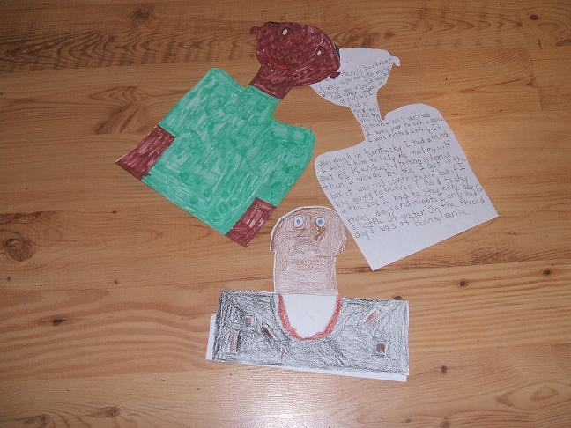
Drawing must resemble a slave—boy, girl, adult man or woman.
Drawing must be neat.
Drawing must be colorful.
Writing must be from slave’s point of view.
Writing must include at least 4 examples of a slave’s life.
Writing must be neat and easy to read.

Sample Criteria chart for drawing of escape to freedom:

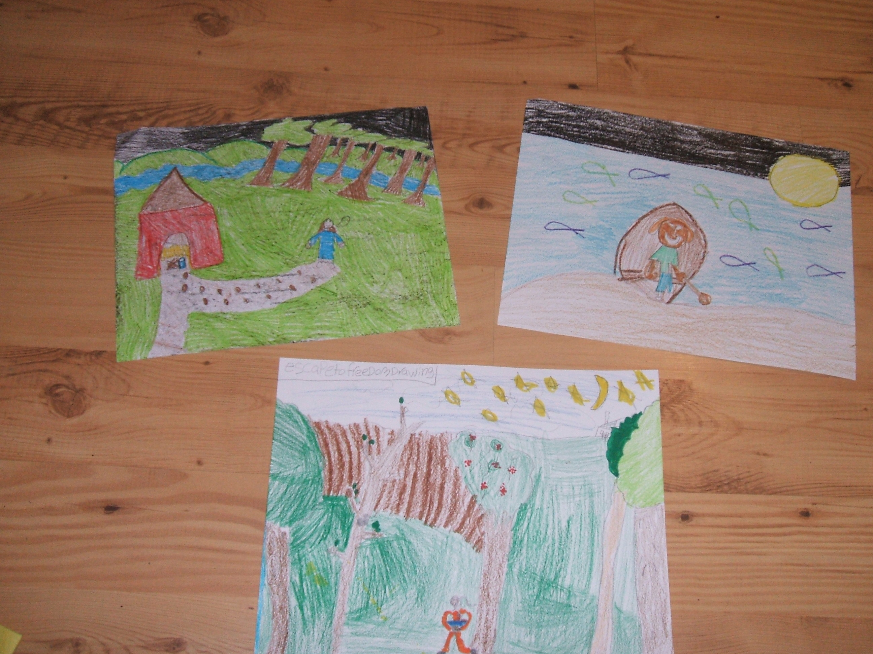

Drawing must represent a slave’s escape to freedom—one mentioned in books, or a unique way the student thought of.
Drawing must be colorful.
Drawing must be neat.

Sample Criteria chart for letter:
Letter must be written from slave’s point of view to their mom or dad.
Letter must include 4 or more facts about a runaway slave’s life.
Letter must include all five parts of a letter.
Letter must be neat and easy to read.
- Students are given time to complete any 2 of the activities. They are allowed to
use their notes or alphabet boxes.

Student Assessment:
One type of informal assessment would be to look at the alphabet boxes. If the number of entries on the student’s alphabet boxes increased each time, the student learned or became more familiar with the topic.

Another type of informal assessment would be to look at the learning logs. By reviewing them and talking with the student, the teacher can assess if student is able to write down important facts.

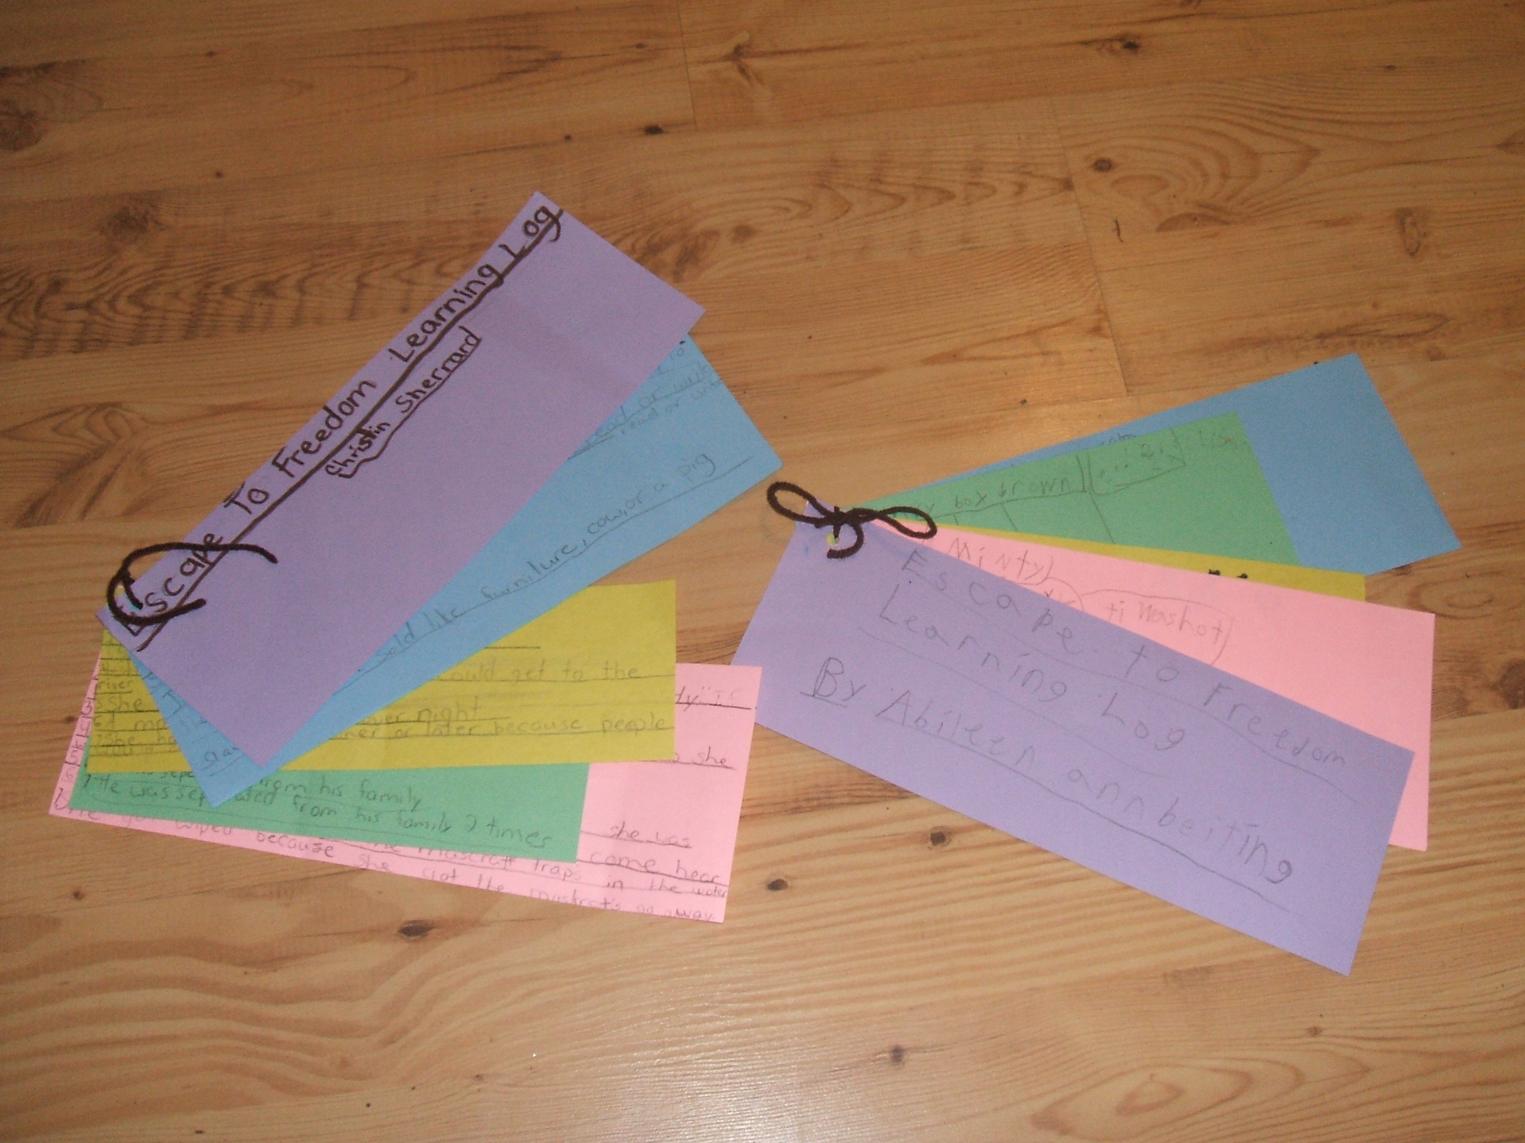

The students work will be based on the following rubrics.

Open-minded portraits
0 points | 1 point | 2 points | 3 points
No writing, or writing is random  ____points | Writing does not relate to slave’s life  _____points | Writing includes 1, 2 or 3 accounts of a slave’s life  _____points | Writing includes 4 or more accounts of a slave’s life  ____points
Not written from slave’s point of view  _____points | Written somewhat from slave’s point of view  _____points | Written mostly from slave’s point of view  _____points | Written totally from slave’s point of view  _____points
Not neat and easy to read  _____points | Somewhat neat and easy to read  _____points | Mostly neat and easy to read  ____points | Very neat and easy to read  _____points
Does not represent a slave in any fashion  _____points | Some parts represents a slave  _____points | Drawing mostly represents a slave  ____points | Drawing represents a slave  ____points
Drawing is not colorful  ___points | Some parts are colorful  ____points | Drawing is mostly colorful  _____points | Drawing is colorful  ___points

TOTAL # OF POINTS_________

Independent 13 to 15 total points
Developing 10, 11 or 12 total points
Beginning 9 or fewer points
Rubric for drawing of an escape to freedom:

1 point | 2 points | 3 points
Drawing is incomplete or does not relate to topic of escape  _____points | Drawing somewhat represents slaves escaping to freedom  _____points | Drawing represents slaves escaping to freedom  _____points
Colors used are not appropriate for drawing  _____points | Colors used are somewhat appropriate for drawing  _____points | Colors used are appropriate for drawing  ____points
Drawing is not neat  ____points | Drawing is somewhat neat  _____ | Drawing is neat  ____points

TOTAL # OF POINTS ________

Independent 8 or 9 points
Developing 6 or 7 points
Beginning 5 or below

Rubric for letter written to mom/dad

1 point | 2 points | 3 points
Letter is not written from slaves’ point of view  _____points | Letter is partially written from slaves’ point of view  ___points | Letter is written from slaves’ point of view  ____points
Letter is written using 0 or 1 facts relating to a runaways’ life  ___points | Letter is written using 2 or 3 facts relating to a runaways’ life  ____points | Letter is written using 4 or more facts relating to runaways’ life  ____points
Includes 3 or fewer parts of a letter  ____points | Includes 4 parts of a letter  ____parts | Includes all 5 parts of a letter  _____points
Letter is not neat or easy to read  _____points | Letter is somewhat neat and easy to read  ____points | Letter is neat and easy to read  __points

TOTAL # OF POINTS ________________

Independent 10, 11 or 12 points
Developing 8 or 9 points
Beginning 7 or fewer points

Artifact discovery worksheet

FEATURES | #1 | # 2 | # 3 | #4
Name of item

description

What item could
be used for

Is item like anything
used today--what

Artifact discovery worksheet

FEATURES | #5 | # 6 | # 7 | #8
Name of item

description

What item could
be used for

Is item like anything
used today--what

