TOPIC: Underground Railroad
LESSON LENGTH: 4 days
GRADE: 2

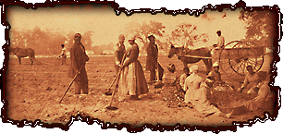
Lessons

OBJECTIVES:
*Students will identify some of the hardships slaves faced on their journey to freedom.

*Students will gain some understanding as to the importance of our geographic region in the Underground Railroad.

*Students will write a letter from the perspective of a runaway slave who made it to freedom with the help of John Parker.

MATERIALS:
- If You Traveled On The Underground Railroad written by Ellen Levine
- Freedom River written by Doreen Rappaport
- Chart paper
- Markers
- “The Freedom Trail” brochure
- Power Point presentation

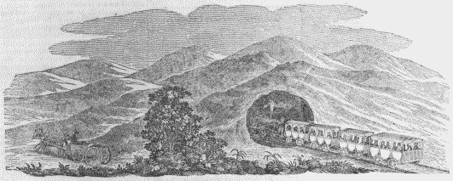

PROCEDURE:
DAY 1
- Discuss with students the freedoms we have in our country today.
- Explain that years ago there were a large group of people who did not have those freedoms.
- Begin reading If You Traveled on the Underground Railroad pages 7-19.
- Students will complete a journal entry “Why do you think the slave owners did not want the slaves to learn to read and write?”
- Have students volunteer to share their responses with the class.

DAY 2
5. Review information gained about the UGRR from the previous lesson.
- Continue reading If You Traveled on the Underground Railroad pages 20-39 and discuss the role Kentucky played in the UGRR.
- In a journal, have students write at least 3 things they learned from today’s reading.

DAY 3
- Review information from yesterday’s lesson.
- Continue reading pages 40-51 in If You Traveled on the Underground Railroad.
10. After reading pages 47-48, stop and have students discuss some of the advantages and disadvantages to leaving at certain times of the year and record on chart paper.
11. Discuss with students that there were many slaves that would run away and black and white people
would help them escape.

DAY 4
- Explain that there is one very important conductor on the UGRR who lived really close to where we
live – John Parker.
- Show students, using a map, where Ripley, Ohio and Augusta and Maysville, Kentucky are
- Show students “The Freedom Trail” brochure.
- Read Freedom River.
- Have students imagine they are the slaves in the story and write a letter to John Parker thanking him for his help and telling him about the freedoms they now have. Students can also illustrate a freedom the runaway slaves have now that they are free (this could be used for students who are unable to write the letter).
- View PowerPoint Presentation of historic sites and artifacts and discuss.

ASSESSMENTS:
- Students demonstrate, through a journal entry, an understanding of the importance of reading and writing to the slaves.
- Students identify three concepts learned about the UGRR.
- Students write a friendly letter (or complete an illustration) from the perspective of the runaway slaves to John Parker and discuss the freedoms they now have.

RESOURCES:
Levine, Ellen. If You Traveled On The Underground Railroad. Scholastic, 1993.

Rappaport, Doreen. Freedom River. Hyperion, 2000.

http://education.ucdavis.edu/NEW/STC/lesson/socstud/railroad/contents.htm includes information about the underground railroad and personal narratives of a few abolitionists.

www.nationalgeographic.com/railroad/ students can take imagine they are a run away slave on the journey north

