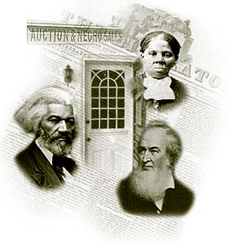
Subject taught: 7th Grade Reading
Topic: Underground Railroad
Elementary Students
Lesson Length: 4-5 days
By: Amy Buerger

Objectives:
- The students will research topics about the Underground Railroad obtained from the Internet and from class.
- The students will demonstrate Underground Railroad knowledge by presenting their information to the class.

Materials and Technology
- Various books from the school library on the Underground Railroad.
- Access to computers, Internet, and PowerPoint.
- Directions for the final product with rubric.
- View the following movies: Race to Freedom

Procedures
- Introduce the lesson by asking the students to brainstorm about the Underground Railroad. Found out what the students already know on the subject. List the items on a poster for the classroom to start developing the KWL chart.
2. View the video Underground Railroad Documentary. Have the students develop questions on what they want to learn about the Underground Railroad. List these questions on a poster. Hang posters in the classroom.
3. Give the students directions for final projects and rubric. Students will choose a partner to work with for the final project.
- View the video the Race for Freedom.
- Have students’ log on to the Internet to do research. Make sure that the students are using a search engine to research the topic. Student should choose a final project and start their research.
- Students should prepare their presentations for class.
- Students will present their final projects to the class.
- Students will finish the KWL chart by completing a poster that tells what they have learned from their research about the Underground Railroad.

Assessment
Students will complete a rubric for working with partners.
Teacher will complete a rubric for class presentation.
Presentations

Rubric Made Using:
RubiStar ( http://rubistar.4teachers.org )
Oral Presentation Rubric : Underground Railroad
Teacher Name: Mrs. Buerger
Student Name: ________________________________________
CATEGORY | 4 | 3 | 2 | 1
Content | Shows a full understanding of the topic. | Shows a good understanding of the topic. | Shows a good understanding of parts of the topic. | Does not seem to understand the topic very well.
Speaks Clearly | Speaks clearly and distinctly all (100-95%) the time, and mispronounces no words. | Speaks clearly and distinctly all (100-95%) the time, but mispronounces one word. | Speaks clearly and distinctly most ( 94-85%) of the time. Mispronounces no more than one word. | Often mumbles or can not be understood OR mispronounces more than one word.
Stays on Topic | Stays on topic all (100%) of the time. | Stays on topic most (99-90%) of the time. | Stays on topic some (89%-75%) of the time. | It was hard to tell what the topic was.
Collaboration with Peers | Almost always listens to, shares with, and supports the efforts of others in the group. Tries to keep people working well together. | Usually listens to, shares with, and supports the efforts of others in the group. Does not cause "waves" in the group. | Often listens to, shares with, and supports the efforts of others in the group but sometimes is not a good team member. | Rarely listens to, shares with, and supports the efforts of others in the group. Often is not a good team member.
Volume | Volume is loud enough to be heard by all audience members throughout the presentation. | Volume is loud enough to be heard by all audience members at least 90% of the time. | Volume is loud enough to be heard by all audience members at least 80% of the time. | Volume often too soft to be heard by all audience members.
Posture and Eye Contact | Stands up straight, looks relaxed and confident. Establishes eye contact with everyone in the room during the presentation. | Stands up straight and establishes eye contact with everyone in the room during the presentation. | Sometimes stands up straight and establishes eye contact. | Slouches and/or does not look at people during the presentation.
 |  | 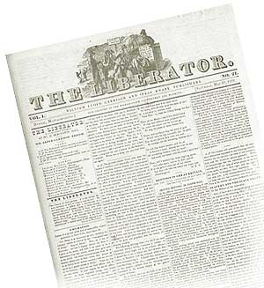 | 