The Underground Railroad

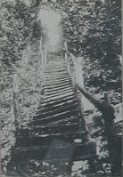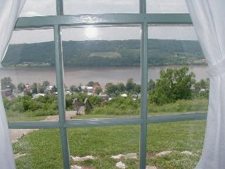

Subject: Social Studies / Writing Grade Level: 5/6
Topic: Participation in the Underground Railroad Lesson Length: 60 minutes

Objectives: 1. Students will use information provided in class and on the Internet to make decisions regarding involvement in the Underground Railroad.
2. Students will compare and contrast reasons for participating in the Underground Railroad.
3. Students will choose to either participate in the Underground Railroad efforts or not participate and then write a letter persuading a friend to do the same.

Materials: 1. Lyrics to Follow the Drinking Gourd
- National Geographic Website: http://www.nationalgeographic.com/railroad/
- Persuasion Map - http://eduplace.com/graphicorganizer/index.html

Procedure: 1. Students will have previously viewed the National Geographic Website: http://www.nationalgeographic.com/railroad/ and learned about the efforts of the Underground Railroad
2. Students will begin by singing Follow the Drinking Gourd
3. Begin the discussion by asking how John Parker, John Rankin and others helped in the Underground Railroad efforts.
4. Discuss stories describing the escape of people such as Henry “Box” Brown, William and Ellen Craft. Discuss how many people had to make decisions concerning the Underground Railroad. These people were slaves, freed blacks, white abolitionists and white slave owners.
5. Each student will complete a Persuasion Map regarding the question of whether or not to participate in the Underground Railroad.
- On the chalkboard create a Pros and Cons Chart combining items from each students’ worksheet.
Have students decide whether or not they would participate in the Underground Railroad choosing to give their view as a slave, freed black, white abolitionist or white slave owner.
- Each student will write a letter to a friend persuading him/her to do the same as they have chosen.
- As the class period ends have the students sing My Old Kentucky Home

Student Assessment: Students must include 3 - 5 reasons for their decision to participate in the UGRR efforts or not. Students must use 2 – 4 counter statements of why someone would not agree with them. Students must also use proper letter format.

Resources: http://www.nationalgeographic.com/railroad/
The Underground Railroad by Raymond Bial
The Promised Land edited by Stuart Steely Sprague
http://www.nps.gov/boaf/ugrrho~1.htm
Notes from EDU 599

