Underground Railroad Lesson Plan

Frank Lowden


Area: Social Studies/American History
Objectives:
- Students will learn about the lives of people involved in the Underground Railroad by producing a newscast of the people, places, and events of the period.
- Students will describe and recognize the role of the abolitionists in the Underground Railroad.
- Students will analyze the social, economic, and political effects of the Underground Railroad in Ripley, Ohio.

Procedures:
- Groups of students will choose a particular abolitionist and/or event to research for the development of a newscast.
- The abolitionist research should include but is not limited to: biographical information, family history, professional life, personal beliefs, and connection to the Underground Railroad.
- The research should also include historical details of Ripley, Ohio and the geographical importance to the Underground Railroad.
- From the chosen people and events, the group will develop and perform a mock television newscast. The newscast must include:
News Anchors
On-location reporters
Weather Person
Sportscaster
Commentary Person
- Students are encouraged to incorporate creativity such as dress up in period costume, include visual aides or graphics, develop maps or models, or any additional ideas they may have to make their presentation unique.
- All newscasts must be typed and then presented to the class in the News Room.
- The newscast will be videotaped for later viewing and analysis.
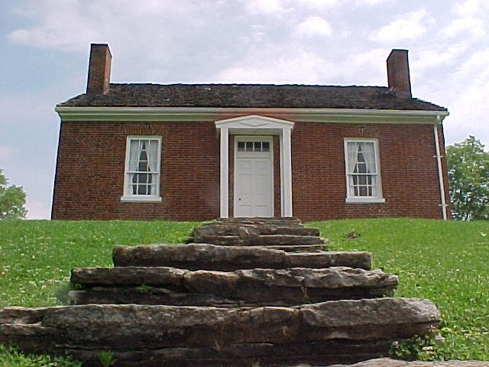

Assessment:
The students will be evaluated using the following rubric.

Write in the appropriate “grade”, in the space provided, with a number (1 through 10), 10 representing a perfect score.

- _____How clear (understandable to the viewer) was the information given in the report?

- _____Did the information, given in the report, cover the appropriate time in history?

- _____How well were the “newscasters” properly prepared (organized)?

- _____How newsworthy would you rate the group’s report?

- _____Was the report between 5 and 8 minutes long?

- _____How well did the reporters show eye contact to the camera?

- _____How smooth was the “transition” (move) from reporter to reporter?

- _____How entertaining would you rate this group's overall broadcast?

- _____How do you rate the “quantity and quality of information” you learn from this report?

- _____How well, would you say, each member of the group participated?

Total: ________ (out of 100 possible points)

Name of the news anchor (which group?): _____________

