Stations on the Underground Railroad
Lesson Plan

Mary Voorhees
Grade 8
2 Class Periods (1 week apart)
Approximately 120 minutes

Objectives

- Students will be able to describe the UGRR and will expand their knowledge of it.
- Students will research short articles and analyze information about some of the UGRR stations in the United States.
- Students will demonstrate their knowledge of UGRR stations by presenting a summary of these articles to the class.
- Student will be able to plot the locations, state by state, of these stations.

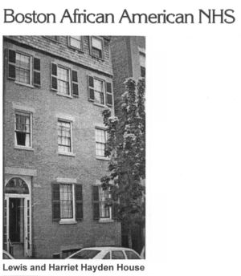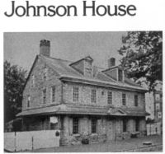

Materials

- Questions for brainstorming and discussion

- List of Stations from the United States and description of each station from articles, obtained on the internet. These articles can be printed and ready to distribute to the students.

- Large map of the United States, left blank, in order to plot the locations of these UGRR stations – to be displayed in the classroom. Also, maps which show 1) UGRR Routes, and 2) Separation of Free, Slave, and Border States at the time of the Civil War.

- Kentucky Historical Timeline for Slavery and the Underground Railroad ~ to be displayed in the classroom.

- United States Historical Timeline for Slavery and the Underground Railroad ~ to be displayed in the classroom.

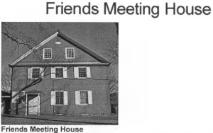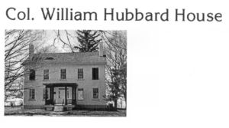

Procedure

Please note: One half of this lesson was presented the day before this class was to go to Camp Joy in Clarksville, OH for an overnite field trip. One of the activities at the camp was sponsored by the UGRR Freedom Center, in Cincinnati, OH. The students became slaves for the afternoon; they learned how slaves were treated and what it felt like to be one.

- Introduce lesson by discussing what students already know about Underground Railroad Stations – where they might be located, and reasons for their locations.

- Complete together and talk about the questions generated by the teacher education website. This will draw questions from students about free and slave states, conductors, stations, and the difficulty of escape.

- Introduce the Station articles. Make sure there are enough Stations articles to be divided among the students in the class.

- Assign an equal number of articles to each student, to be summarized and presented to the class. The information to be summarized from the Station articles should pertain to their role in the Underground Railroad. The students will have one week to prepare their summaries.

- After the summary presentations are completed, give each student a chance to plot the location of their stations on the blank map of the United States. Talk about the plotted map and how it pertains to escape activity in free and slave states.

Assessment

Students will be monitored for active participation in the introductory/brainstorming discussion questions.

Presentations will be assessed by how well the students demonstrate full knowledge of the events that occurred
at the UGRR stations being summarized. Presentations should be well planned. Other criteria to be monitored will include: length of summaries, and mechanics of presentation such as voice, eye contact, and stance. These presentations are intended to broaden the audiences’ knowledge of UGRR stations.

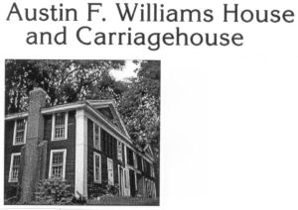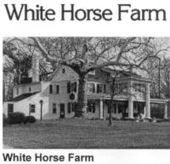

Resources

**Teaching website for UGRR questions:

http://www. edHelper.com

**List of UGRR Stations in the United States:

http://www.cr.nps.gov/nr/travel/underground/states.htm

**Slavery/UGRR Timelines:

http://www.ket.org/underground/timeline/kytime.htm
http://www.ket.org/underground/timeline/ustime.htm

United States Map (Blank) can be made by hand, using an overhead projector to enlarge the size of a small map. Or, a blank map can be found at edHelper.com.

