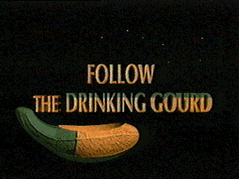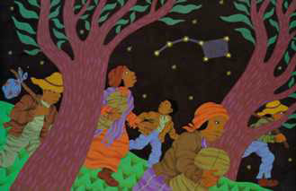

Rebecca Rossiter 1st Grade (Primary 2)

Slavery and the Underground Railroad

Goals and Objectives:
Students will understand the historical context of slavery and the Underground Railroad movement. Students will recognize the role the Northern Kentucky geographical area played in the Underground Railroad. Students will understand the negative impact of slavery and how historical events affect today’s society.

Essential Questions:
What is slavery?
When and why did slavery exist?
Why did some slaves choose to escape?
What is the Underground Railroad?
How did slaves find their way to freedom?
What were some of the dangers fugitive slaves faced?
What is a constellation?

Connections:
SS-E-2.1.1 Language, music, art, dress, food, stories, and folk tales help define culture and may be shared among various groups. (discussion of African-American culture and customs during the time of slavery; reaction to book Follow the Drinking Gourd and United Streaming video on slavery in Kentucky)
SS-E-3.1.1 Scarcity requires people to make choices about using goods, services, and limited resources. (discussion of lack of resources for fugitive slaves)
SS-E-3.1.3 Every time a choice is made, an opportunity cost is incurred. Opportunity cost refers to what is given up when an economic choice is made. (discussion of why slaves attempted escape; what choice would the students make; use book Follow the Drinking Gourd and United Streaming video on slavery in Kentucky to prompt discussion questions)
SS-E-4.1.3 Mental maps are used to demonstrate where things are and how they are arranged. (Peg Leg Joe taught the slaves a song about the “drinking gourd”. Slaves used the song as a secret code to find the North Star to escape to freedom.)
SS-E-4.4.1 People depend upon the physical environment for food, shelter, and clothing. (relate to Underground Railroad and resources found/used between and at each stop)
RD-E-2.0.8 Identify main ideas and details that support them. (Read and discuss Follow the Drinking Gourd)
RD-E-2.1.10 Connect the content of a passage to students’ lives and/or real world. (discussion of Underground Railroad, role of this geographical area in the freedom movement, and events depicted in Follow the Drinking Gourd)
SC-E-2.2.2 Objects in the sky (e.g., Sun, clouds, moon) have properties, locations, and real or apparent movements that can be observed and described. (Big and Little Dipper constellations, North Star)

Context:
The major focus of this lesson is to provide the students with background information about the history of slavery in our country and to introduce them to the concept of the Underground Railroad. Since the students are only in first grade, this lesson is generally their initial introduction to the concept of slavery. Most of the students have no prior knowledge on this subject. I want them to become aware of the history of slavery as well as the Underground Railroad, especially as it relates to the Northern Kentucky geographical area. Students need to understand how past historical events relate to today’s society and why certain events (e.g., Civil War, Civil Rights Movement, etc.) occurred. This lesson encourages cultural awareness and racial tolerance. Also, the lesson incorporates earth science in the observation of constellations, specifically the Big and Little Dipper. Students also learn about the North Star and how to use the stars as a guide.
The first step in teaching the concept of the Underground Railroad is to explain that it is not in fact a railroad, nor is it underground. Since a first grade mind is quite literal, this must be explained immediately in order to set the right foundation for the lesson. The following picture depicts a stop on the Underground Railroad. Students can use these types of pictures to understand the concept and to alleviate any misconceptions.

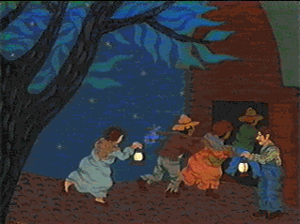

Resources:
The Dupont Planetarium: Follow the Drinking Gourd. Retrieved November 4, 2005, from http://rpsec.usca.sc.edu/Planetarium/gourd.html
The Educator’s Reference Desk. Follow the Drinking Gourd. Retrieved November 4, 2005, from http://www.eduref.org/cgi- bin/printlessons.cgi/Virtual/Lessons/Social_Studies/History/HIS0014.htm
Follow the Drinking Gourd. Retrieved November 4, 2005, from http://www2.lhric.org/pocantico/tubman/gourd.htm
Follow the Drinking Gourd. Retrieved November 4, 2005, from http://www.nationwide.net/~amaranth/gourd.htm
KET: Kentucky's Story: Slavery in Kentucky. Kentucky Educational Televison (1993). Retrieved November 4, 2005, from unitedstreaming: http://www.unitedstreaming.com/
Northern Star Plantetarium. Retrieved November 4, 2005, from http://www.northern- stars.com
Question Cards for Follow the Drinking Gourd. Retrieved November 4, 2005, from http://www.siue.edu/EDUCATION/AAM/lesson/gallagher/AAM%20webpage/Q uestion%20cards%20for%20drinking%20gourd.htm
The Educator’s Reference Desk. Follow the Drinking Gourd. Retrieved November 4, 2005, from http://www.eduref.org/cgi- bin/printlessons.cgi/Virtual/Lessons/Social_Studies/History/HIS0014.htm.
Winter, J. Follow the Drinking Gourd. New York, NY: Alfred A. Knopf, INC., 1988.

Procedures:
- Watch United Streaming video entitled Kentucky’s Story: Slavery in Kentucky. This will provide students some initial exposure to the concept of slavery. Discuss video and answer any questions students may have. Introduce concept of slavery as well as the Underground Railroad and provide historical context and timeline.
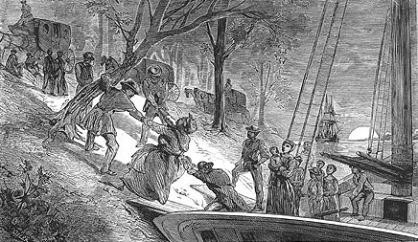
Fugitive slaves escaping to freedom on the Underground Railroad
Photograph courtesy of the New York Public Library

2. In groups, look at question cards from website (http://www.siue.edu/EDUCATION/AAM/lesson/gallagher/AAM%20webpage/Q Divide students into four groups. Each group discusses five questions about the pictures and then shares their discussion with the class. To see list of questions and print out the appropriate pictures for each group, visit the above website.

3. Read and discuss book Follow the Drinking Gourd by Jeanette Winter. Tell the relationship of a drinking gourd to the Little Dipper as well as the use of secret codes in the song. Show students pictures of a drinking gourd or an actual gourd that has been cut out.

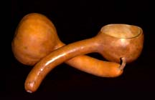
http://rpsec.usca.sc.edu/Planetarium/gourd.html

4. Discuss the meaning of the lyrics in the song “Follow the Drinking Gourd” that Peg Leg Joe taught the slaves. Introduce the concept of constellations and show students the constellations of the Big and Little Dipper, with special emphasis on the North Star. Teach students the song “Follow the Drinking Gourd”. Tune of song can be found at http://www.nationwide.net/~amaranth/gourd.htm.

5. Students make reaction pictures about what they read in the book or what they learned during our class discussion. Students choose something the most impacted them and draw a picture depicting a specific scene or event.

6. Constellations page: Give each student a piece of black construction paper and a copy of the printout of the Big Dipper, Little Dipper, and North Star. Students place the constellations on top of their black construction paper. Using a thumbtack (be careful!), make holes through each star that makes up the constellations. Remove the constellations printout from the black paper. Using a white crayon, students make circles in the spots they poked the holes and then connect the stars to form the constellations. Label the paper with the title “Follow the Drinking Gourd”. Also label the names of the constellations and the North Star.

7. Review the lesson. Discuss what students have learned and answer any questions they may still have. Check for understanding of the content through questioning techniques and having students explain the events to others.
(This lesson needed little adaptation for students with IEPs. Directions were broken down into easily followed steps and students remained focused and on-task through questioning and lively class discussion.)

Student Assessment:
Participation during class discussion and singing of song “Follow the Drinking Gourd”; ability to choose and depict one historically accurate scene or event from class discussion, book Follow the Drinking Gourd, or video on slavery in Kentucky to make a reaction picture; correct completion of constellations page.
This lesson was mainly intended to provide students with background information on a new topic. Participation in the discussion through asking and answering questions is vital to show understanding.

Impact:
This lesson had high positive impact. I was pleasantly surprised by the interest of my students in this topic. While they began the lesson with little to no prior knowledge of slavery or the Underground Railroad, students participated in the lesson and asked interesting and thought-provoking questions. They seemed to truly understand the content and wanted as much information as I could give them. Students were able to make connections to today’s world, and they took from the lesson an understanding of an important historical event in our country’s past as well as an increased awareness and tolerance of cultures and races in their own world. Many students returned the next day and said they talked to their parents about the Underground Railroad and they had new questions to ask me. Also, students were surprised to discover the role our own region played in the Underground Railroad. We discussed the role of the Ohio River and how there were stops on the Underground Railroad in our area. This made the information much more real to them and provided them with even more motivation to learn.

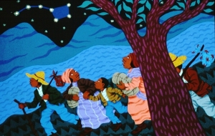

Refinement:
These activities really should be divided up into more than one lesson to provide adequate time. I ended up having to continue the lesson the next day in order to do all activities planned. Since the students were so interested and involved, this was very easy to continue. They retained the information from the previous day, and continuing the lesson enabled us to review and extend our learning about the topic.

Lesson Extension/Follow-up:
I taught this lesson towards the end of October, and Rosa Parks happened to pass away soon after. I was able to tie in the Civil Rights Movement to what we had previously learned about slavery and the Underground Railroad. Students were better able to understand our discussion of Rosa Parks now that they had some background knowledge of the history of the treatment of African Americans in our country.

