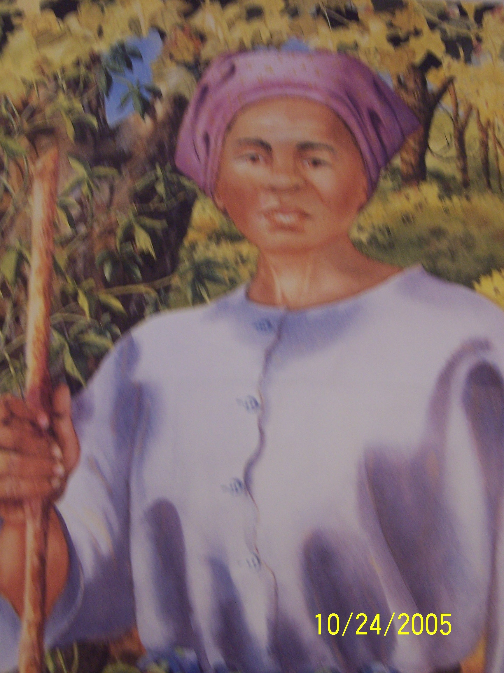
They called her Moses.
A message in code.
Topic: Reading and The Underground Railroad
Grade Level: 3rd and 4th grade
Lesson Length: 45-60 minutes each lesson
- Second lesson- Venn Diagram
- Third lesson – Message to the conductor

OBJECTIVES:
Students will make connections between terms used from the Underground Railroad and apply them.

Students will compare and contrast (Venn Diagram) different concepts used during the Underground Railroad.

Students will create their own secret code message for a conductor on the Underground Railroad.

MATERIALS/TECHNOLOGY:
Freedom Crossing – by Margaret Goff Clark
Aunt Harriet’s Underground Railroad in the Sky – by Faith Ringgold
Follow the Drinking Gourd – by F.N Manjo
Religion Textbook or Bible
Copy of a Venn Diagram for each student
Large Poster Board
Learning Logs

PROCEDURES: Second Lesson
- Students will be reading pages 58-71 Freedom Crossing.
- Review who Moses the prophet was in the bible. Example: Where did he come from? Family life? What did he do? What makes him important? Use religion books or bible for facts and information
- Give each student a copy of the life of Harriet Tubman- found in the back of Aunt Harriet’s Underground Railroad in the Sky.
- Discuss who she was, what she did, where she came form, why she is famous.
- Review what a Venn diagram is and how it works.
- Give each student a copy of the Venn diagram. Have them create a Venn diagram comparing Moses the prophet and Harriet Tubman the conductor.
- Pair students up in groups.
- Write at least 5 concepts or ideas in each heading.
- When groups finish allow them the time to compare other ideas about the Underground Railroad. EXAMPLE: Today’s Railroad to the Underground Railroad, Free man to a slave.

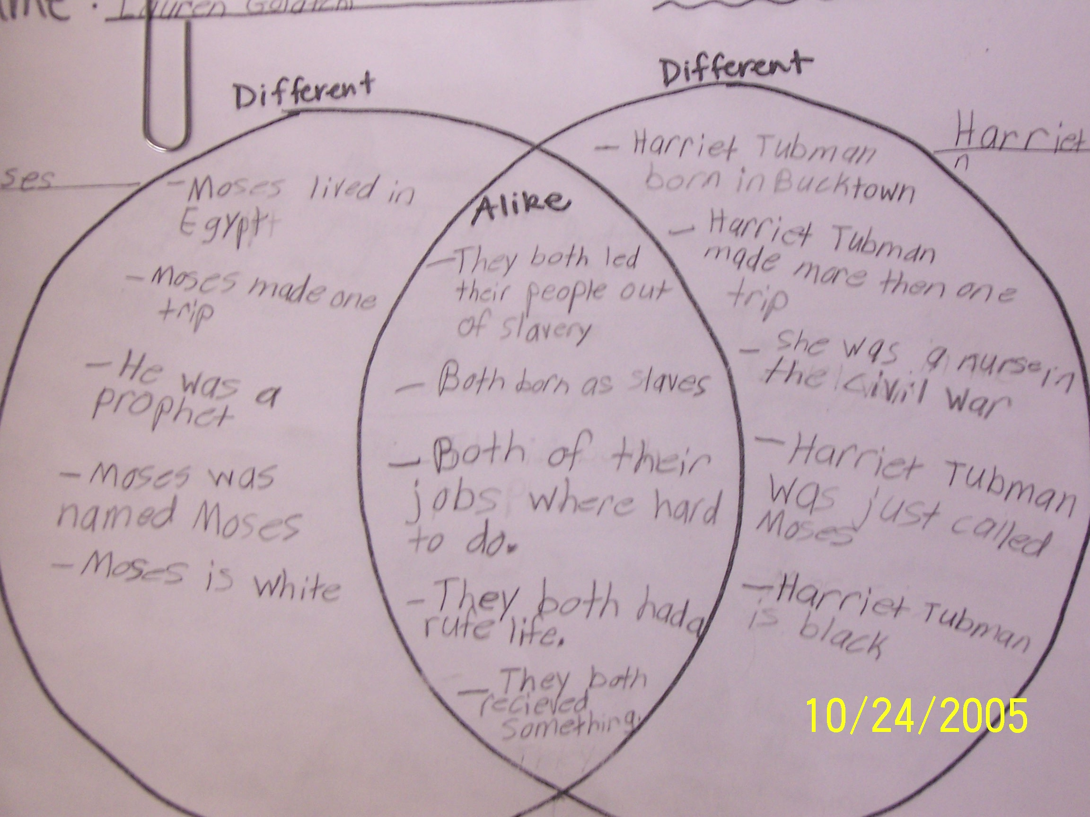

STUDENT ASSESMENT:
Collect Venn diagrams from each student and grade accordingly.
Allow students to share their ideas or concepts.
Participation in group work.

PROCEDURES: Third Lesson
- Students will be reading pages 72-90 Freedom Crossing
- Review with students the code terms used on the Underground Railroad. EXAMPLES: abolitionist – conductor, Grand Central Station- Ohio, River of Jordan- Ohio, Packages- slaves, Hardware- male slaves, Dry goods- woman slaves…
- Have students write in their learning logs a code to let a conductor know that they have a slave at their home that needs to carried to freedom. (10 minutes)
- Gather as large group and share key ideas that would help the message be read smoother.
- Break into small groups (3-4 students) have each group come up with one message combining ideas already written. (20 minutes)
- Gather as large group and compose a class letter to a conductor using the best concepts for all letters written as a group. Teacher guided for maximum details.
- Hang letter in classroom.

STUDENT ASSESSMENT:
Collect journals.
Collect group messages.
Student Participation.

RESOURCES:
Aunt Harriet’s Underground Railroad in the Sky by Faith Ringgold
Many Thousand Gone by Virginia Hamilton
Freedom Crossing by Margaret Goff Clark
Freedom Trail by Dorothy Sterling
EDU 599 or HIS 594 class notes
