Subject: Social Studies Grade Level: 3rd grade
Major Content: The Underground Railroad Length: approximately 2 weeks

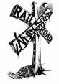
Lesson Objectives:
1. Students will develop an understanding of the important people and places that impacted slavery and the Underground Railroad.
- Students will identify vocabulary related to slavery and the Underground Railroad.

Materials:
- Social Studies Textbook/ other materials to introduce civil war and slavery
- Sweet Clara and the Freedom Quilt by Deborah Hopkins (Class set)
- If You Traveled on the Underground Railroad by Ellen Levine (Class set)
- Map of the United States with map scale (map with scale for each student)
- Encyclopedias, Internet access, books related to people of the Underground Railroad
- Power point program

Procedures:
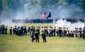

Day 1

- Introduce the Civil War and slavery using given textbook or other resources. The Civil War web site provided, under the resources below the unit, has a plethora of information that may be helpful.
- Complete the know and what you want to know portion of a K-W-L chart about the Civil War, Underground Railroad, and slavery.
- Jigsaw activity using book, If You Traveled on the Underground Railroad. The book is divided up into questions by chapters. Students will be assigned partners and questions from the book (the book may be too lengthy and you may want to choose the questions you feel are most important). Students must find the answer to their question and support their answer with at least four details from the reading. See attached activity sheet. On the activity sheet, we included only twelve of the most important questions (and combined others) we felt the students would need to answer, however, you may want to alter this to suit your students’ needs.

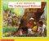

Day 2

- Jigsaw activity continued: Students will share their answers from the previous day by rotating to different partner groups.

First five minutes:
- First partner group will teach the answer to their question.
- Second partner group will write the answer to the question on the activity sheet while it is being taught.
Second Five minutes:
- Second partner group will teach the answer to their question.
- First partner group will write the answer to the question on the activity sheet while it is being taught.
This will continue until all questions are taught and answered.

Day 3. 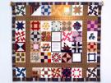

- Discuss key vocabulary terms:
  - Underground Railroad- secret means to take runaway slaves from the south, north to freedom
  - Jordan River- referred to the Ohio River where slaves would cross over into the North
  - Canaan- The Promised Land, or Canada, the ultimate land of freedom.
  - Grand Central Station- Cincinnati, Ohio and Covington, Kentucky
  - Midnight- Detroit, the way to Canada
  - Passenger- runaway slave
  - Agent- people who arranged passage for fugitives.
  - Fugitive- Runaway slave
  - Conductor- A person who would lead the fugitives or passengers to freedom
  - Depot/Terminal/Safe houses- safe places along the route to freedom
  - Packages- men and women passengers
  - Hardware- men
  - Dry good- women
  - Lifeguard- free man of color that patrolled the Ohio River for escapees.

- Read Sweet Clara and the Freedom Quilt- Discuss these terms as reading the book.
- Students create a class freedom quilt. Using light colored/white construction paper, each student or pair of students will receive one vocabulary term. On the construction paper, they must define the term and create an illustration. When students finish, the construction paper can be put together/hung up to represent a quilt.

Day 4: 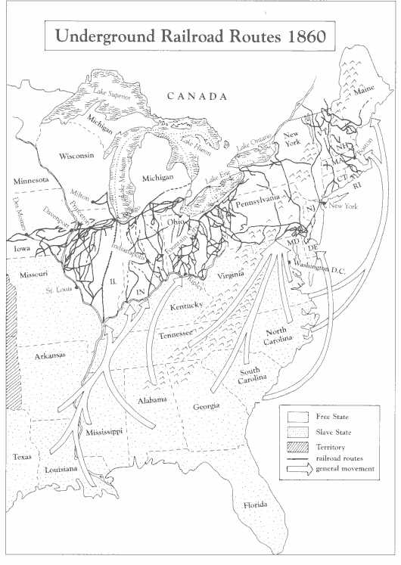
Map Scale activity- Students will receive a map of the United States with a map scale on it. Given a place in the south, students use the map scale to determine the distance from that place to Ripley, Ohio, one of the main stops on the Underground Railroad. Students will be able to see the distance that many slaves traveled on their journey to freedom. On the map, students will also color the slave states red, and the abolition states blue. They will trace the journey from the place in the south to Ripley, OH.
- Introduce and share expectations of the Power Point presentation:
Assign partner groups an important person or place affiliated with the Underground Railroad.
Possible people and places:
John Parker
Harriet Tubman
Nat Turner
John Rankin
Levi Coffin
Box Brown
Eliza’s Crossing of the Ohio River
Frederick Douglass
Harriet Beecher Stowe
Margaret Garner
William and Ellen Craft
Ripley, OH
Augusta, KY

Day 5 & 6: 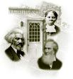

1. Students will research using encyclopedias, Internet, and any other additional resources.

Day 7 & 8: 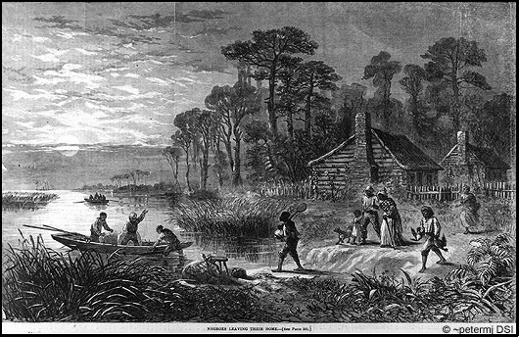

1. Students will create a Power Point presentation, with 4-5 slides, demonstrating their knowledge about the significance of their person or place and their connection with the Underground Railroad.

Day 9: 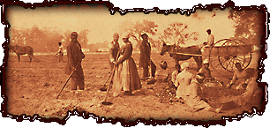

1. Students will share presentations with the class. As a whole class, students will help create the learned portion of the K-W-L chart.

Assessment:

Students will be assessed on their knowledge of the key vocabulary terms, and the significance of the important people and places connected with the Underground Railroad.
See Attached Quiz and Open-Response Question

Resources:

Books:
- If You Traveled on the Underground Railroad, by Ellen Levine
- Journey to Freedom: A Story of the Underground Railroad, by Courtni C. Wright
- Harriet Tubman, by Kathie Billingslea Smith
- You Don’t Own Me, by Melissa Stone
- The Last Safe House: A Story of the Underground Railroad, by Barbara Greenwood
- Frederick Douglass Fights for Freedom, by Margaret Davidon
- The Story of Harriet Tubman, Conductor of the Underground Railroad, by Kate McMullan
- Blue or Gray? A Family Divided, by Kate Connell

Internet Sites:
- http://www.ugrr.org
- http://www.nationalgeographic.com/features/99/railroad
- http://www2.lhric.org/pocantico/tubman/tubman.html
- http://sunsite.utk.edu/civil-war/warweb.html
- http://www.ket.org/underground/

