Stories of the Underground Railroad

Subject: Social Studies and Language Arts

Grade: 4
Topic: Underground Railroad Stories

Time: Four sixty minutes teaching sessions

Objectives:
- Students will be introduced to stories of the Underground Railroad.
- Students will practice reading skills of prediction, clarification, questioning and summary.
- Students will teach their storybook about the Underground Railroad to other students.

Materials:
Five copies of each of the following books:
The Daring Escape of Ellen Craft by Cathy Moore
Freedom River by Doreen Rappaport
Follow the Drinking Gourd by Jeanette Winter
Sweet Clara and the Freedom Quilt by Deborah Hopkinson
Under the Quilt of Night by Deborah Hopkinson
Book Teaching Plan Sheet (attached)
Construction paper, markers, crayons, glue, and other various art supplies.

Internet Resources:
http://www.freedomcenter.org
Story of Box Brown: http://www.freedomcenter.org/index.cfm?fuseaction=home.viewPage&page_id=8EF4FF5C-72F8-401F-B5B1D925068F8E4B
Story of John Fairfield: http://www.freedomcenter.org/index.cfm?fuseaction=home.viewPage&page_id=C53EB8A5-7738-49D0-A37DD29B49EF0CE3

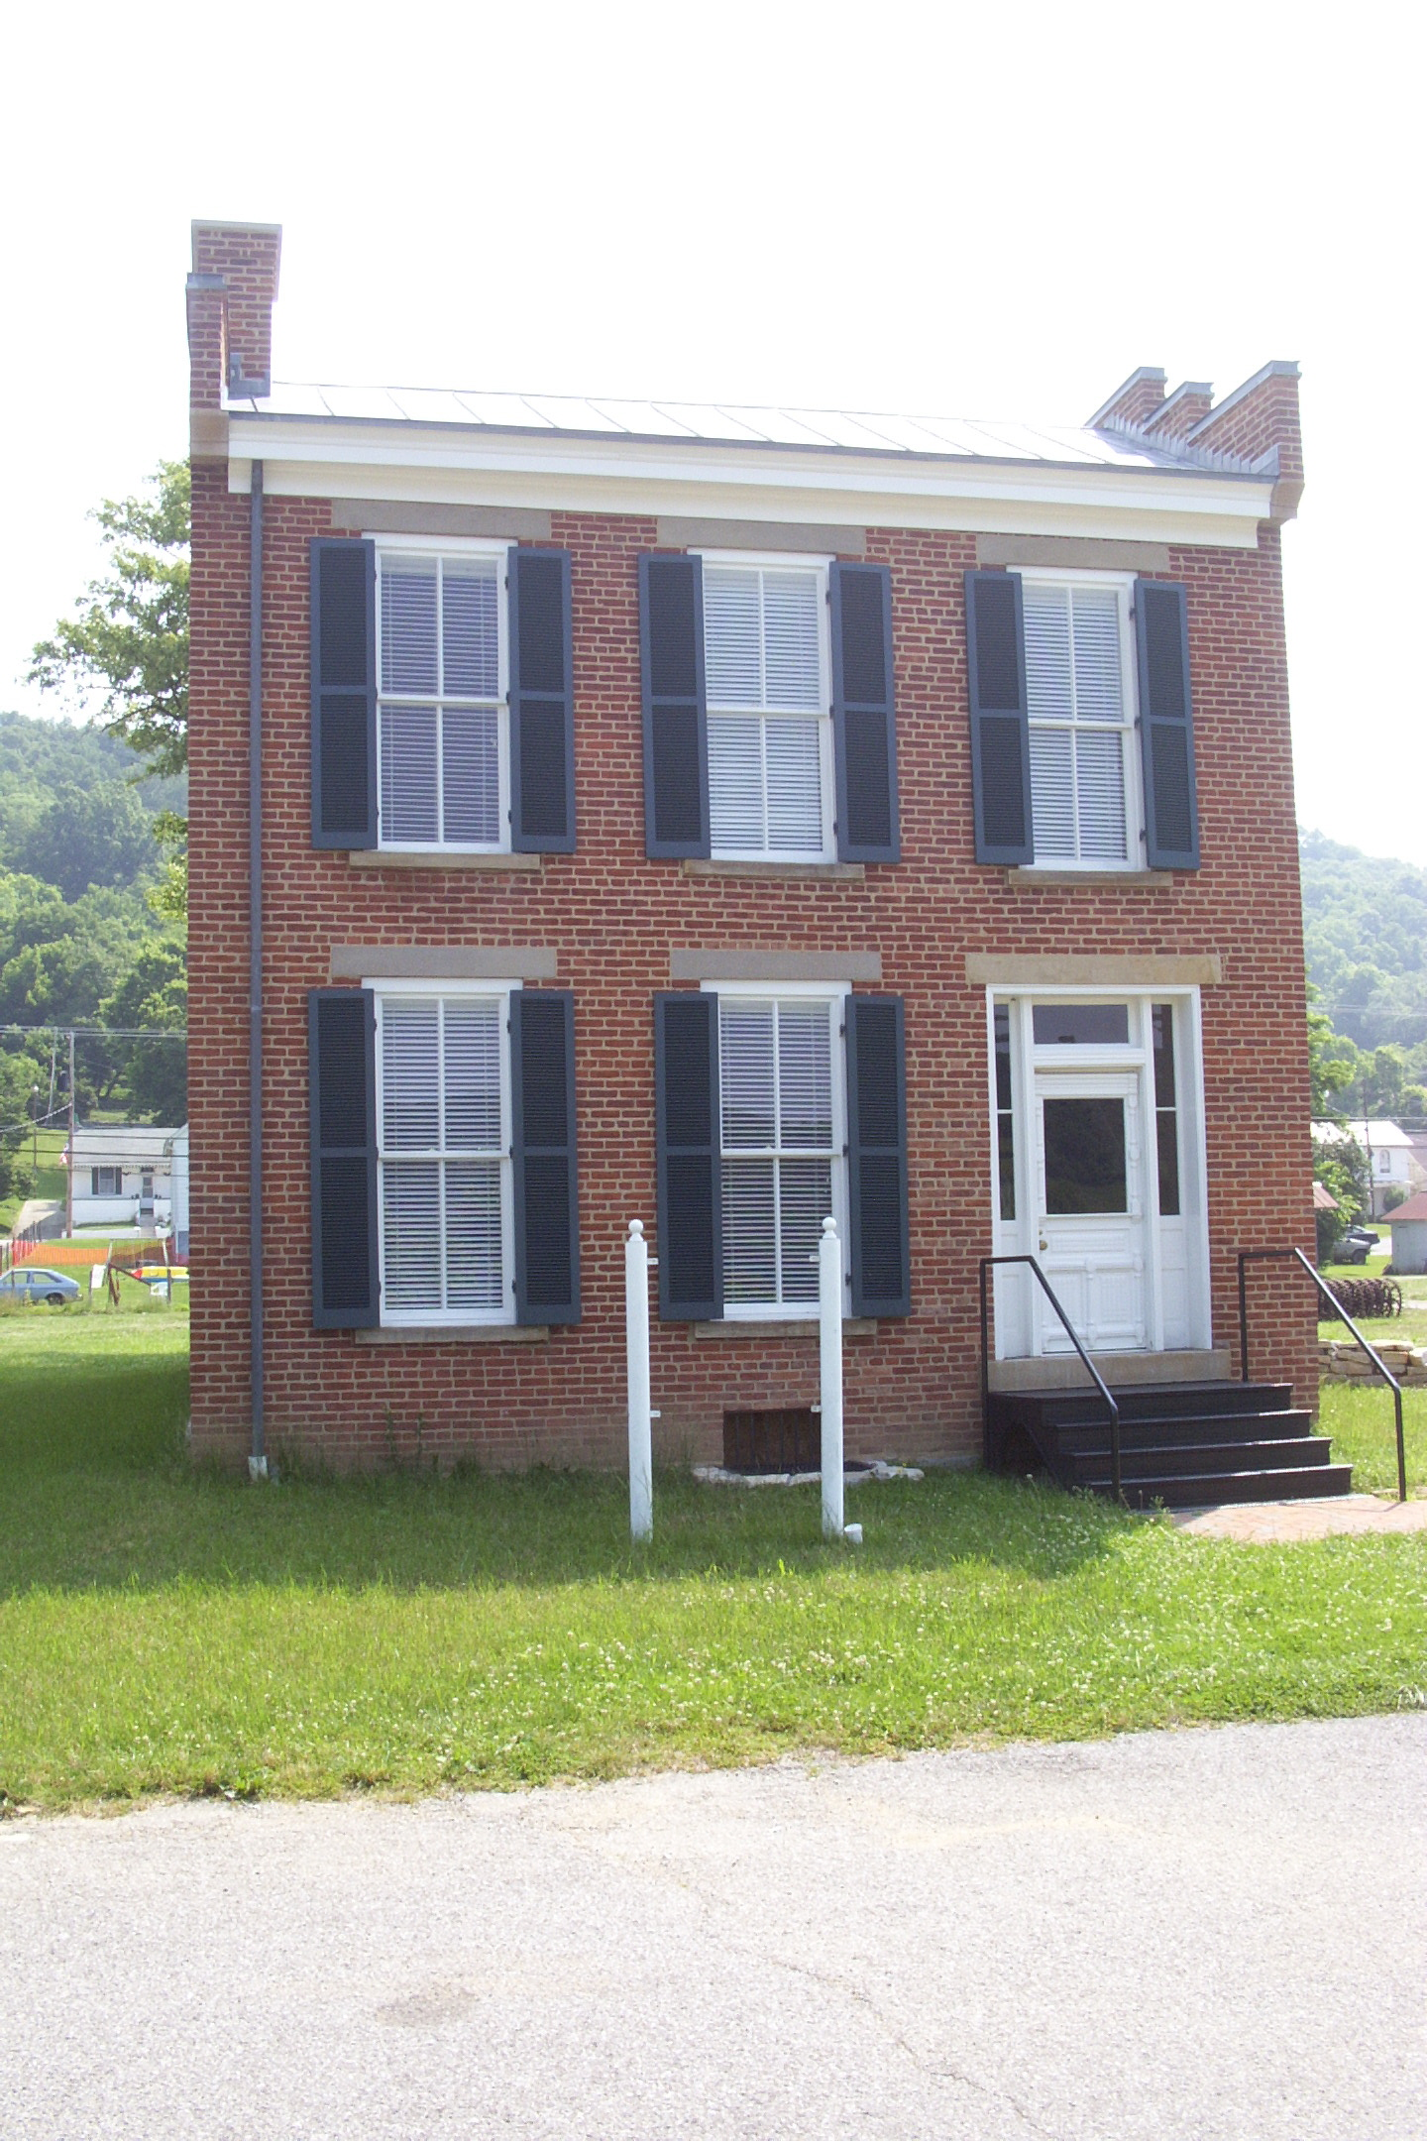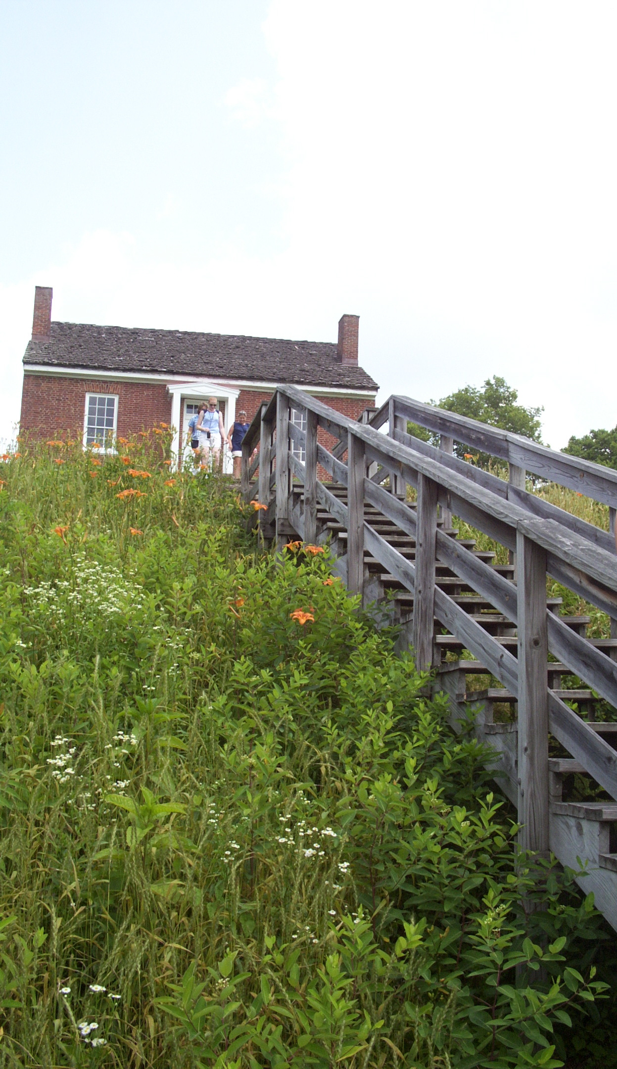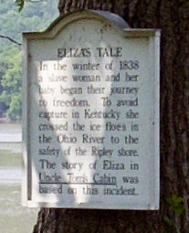
John Parker House John Rankin House A marker retelling the story
Ripley, Ohio Runaways used these of Eliza crossing the Ohio River.
steps to escape.
Procedures:

Day 1
Introduce the Underground Railroad to the class. Provide pictures of John Parker and John Rankin’s homes. Discuss the history of the Underground Railroad in our area. Teacher tells oral stories about the Underground Railroad to develop an interest: Eliza, Box Brown, and John Fairfield. Have the students retell their favorite story through writing.

Day 2
- Divide the class into five groups, assign each group a book and give them a book teaching plan sheet.
- Each group predicts what their book is about.
- Glance through the book for vocabulary that is new or information that needs clarification.
- Read the book aloud as a group.
- Make clarifications about the book. Do you see confusing words or ideas? What happened and do you understand?
- Ask questions about the book. What do you know about the characters’ life? What drove them to take the chance of running away? Who do you relate to in the story? What character is most like you?
- In three or four sentences summarize the book.
- Be sure the book teaching plan sheet is complete.
Each group should now be the experts on the book they read.

Day 3
The students will create a story quilt for their book. Each student takes a part of the story and creates a picture to represent that part of the book. They include a “golden line” or sentence from the book that tells about the picture. Each picture is glued onto a larger page to create the quilt. The students will use the quilt and book teaching plan sheet to teach the book to the class on day 4.

Day 4
- Each group presents their book to the class.
- The students will do a “book talk” on their book using the information from their book teaching plan chart. They become the teachers/ experts on that book.
- Students present the book quilt to demonstrate what they learned from the book.
- Students are encouraged to ask questions about the books. They need to search for how the stories were similar and how they were different?

Assessment:
Completed book teaching plan sheet.
Book Quilt

Book Teaching Plan Sheet

Book Title: _______________________________________________________________________
Group Members:___________________________________________________________________

- Predict what the book is going to be about. Look at the cover, the title, flip through and look at the pictures. What do you think the book will be about? _____________________________________________________________________________________________________________________________________________________________________________________________________________________________________________________________________________________________________________________
- Preview the book. What words look like new words? ______________________________________________________________________________________________________________________________________________________________________________________________________________
- Read the book aloud as a group. Take turns by reading a page.
- Make clarifications. What words or ideas were confusing? What happened in the story? Do you understand the story?
- Discuss the book by answering questions. Use these or come up with your own. What do you know about the characters life? What drove them to take the chance of running away? Who do you relate to in the story? What character is most like you? If you were an enslaved person would you run away or stay with your master? Why or why not? Would you be a helper on the Underground Railroad? Why or why not? What would you want to tell people about the Underground Railroad that you learned from this book?
- In three or four sentences, summarize this book.

Rubric for Book Quilt
Student Name: ________________________________________
CATEGORY | 4 | 3 | 2 | 1
Creativity | Several of the graphics or objects used in the quilt reflect an exceptional degree of student creativity in their creation and/or display. | One or two of the graphics or objects used in the quilt reflect student creativity in their creation and/or display. | One or two graphics or objects were made or customized by the student, but the ideas were typical rather than creative. | The student did not make or customize any of the items on the quilt square.
Time and Effort | Class time was used wisely. Much time and effort went into the planning and design of the quilt. It is clear the student worked at home as well as at school. | Class time was used wisely. Student could have put in more time and effort at home. | Class time was not always used wisely, but student did do some additional work at home. | Class time was not used wisely and the student put in no additional effort.
Attention to Theme | The student gives a reasonable explanation of how every item in the quilt is related to the book. For most items, the relationship is clear without explanation. | The student gives a reasonable explanation of how most items in the quilt are related to the book. For many of the items, the relationship is clear without explanation. | The student gives a fairly reasonable explanation of how most items in the quilt are related to the assigned book. | The student's explanations are weak and illustrate difficulty understanding how to relate items to the book.

Rubric for Book Presentation

Student Name: ________________________________________
CATEGORY | 4 | 3 | 2 | 1
Preparedness | Student is completely prepared and has obviously rehearsed. | Student seems pretty prepared but might have needed a couple more rehearsals. | The student is somewhat prepared, but it is clear that rehearsal was lacking. | Student does not seem at all prepared to present.
Comprehension | Student is able to accurately answer almost all questions posed by classmates about the topic. | Student is able to accurately answer most questions posed by classmates about the topic. | Student is able to accurately answer a few questions posed by classmates about the topic. | Student is unable to accurately answer questions posed by classmates about the topic.
Collaboration with Peers | Almost always listens to, shares with, and supports the efforts of others in the group. Tries to keep people working well together. | Usually listens to, shares with, and supports the efforts of others in the group. Does not cause "waves" in the group. | Often listens to, shares with, and supports the efforts of others in the group but sometimes is not a good team member. | Rarely listens to, shares with, and supports the efforts of others in the group. Often is not a good team member.

