Underground Railroad Lesson Plan

Teresa Cox-Benson Lesson length: 3 days 4th grade Language Arts

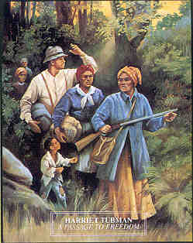

Objectives:
- Students will define and recognize the different aspects of the Underground Railroad.
- Students will outline the different escape routes of the Underground Railroad.
- Students will assess the injustice of slavery.
- Students will investigate the life of Harriet Tubman through literature.

Materials:
Chart paper markers map of escape routes
Underground Railroad timeline

The following children’s literature books:
Young Harriet Tubman Freedom Fighter
Harriet Tubman and Black History Month
A Picture Book of Harriet Tubman

Journey to Freedom

Minty

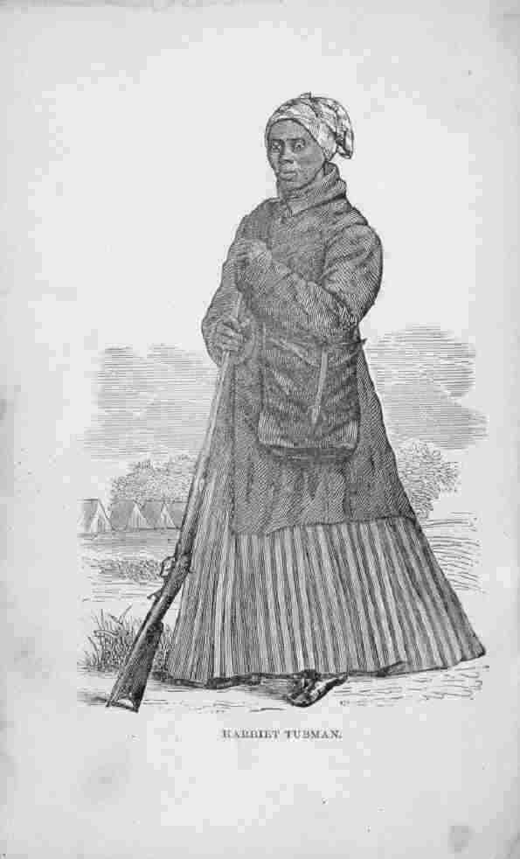
Procedures:
- Begin the lesson by asking the students what they already know about the Underground Railroad and address any myths or misconceptions.
- Using the above literature books, organize students into small groups having approximately 5 students per book.
- Allow the students to preview their book by taking a picture walk and write down predictions in their journals.
- After each group has read their book, they will list on chart paper new things they learned from their reading and list any questions they still have after reading.
- Next, each group will present their charts and the class will help to address any remaining questions from the group’s list.
- Using the map and timeline, discuss the escape routes and timeline of events.
- Also, as a whole group, discuss and list the pros and cons of trying to escape from slavery.
- After the discussion, students will imagine they are an enslaved person and decide if they would risk escape. They will write an essay expressing their views and reasons for their decision.
- In closing, students will read their essays to the class.

Assessment:
- Students will be assessed informally for understanding as they read with their groups.
- Student journals will be evaluated for understanding.
- Group charts will be checked for correct content.
- Written essays will be scored according to a writing rubric.

